788
Atzimba Avellaneda; Nicholas Hux; Jake Miller; Jacob Schmitt; Connor A. Zhou
FAMU-FSU College of Engineering 2525 Pottsdamer St. Tallahassee, FL. 32310

Team 502: NASA Student Launch
8/28/2017

Keywords: list 3 to 5 keywords that describe your project.

Disclaimer
Your sponsor may require a disclaimer on the report. Especially if it is a government sponsored project or confidential project. If a disclaimer is not required delete this section.

Acknowledgement
These remarks thank those that helped you complete your senior design project. Especially those who have sponsored the project, provided mentorship advice, and materials. 4

- Paragraph 1 thank sponsor!
- Paragraph 2 thank advisors.
- Paragraph 3 thank those that provided you materials and resources.
- Paragraph 4 thank anyone else who helped you.

Table of Contents
Disclaimer iii
Acknowledgement iv
List of Tables viii
List of Figures ix
Notation x
Chapter One: EML 4551C 1
1.1 Project Scope 1
1.1.1. Project Description 1
1.1.2. Key Goals 1
1.1.3. Market 2
1.1.4. Stakeholders 3
1.1.5. Assumptions 4
1.1.6. Conclusion 5
1.2. Customer Needs 6
1.2.1. Customer Definition 6
1.2.2. Questions, Statements, and Needs 6
1.2.3. Explanation of Results 12
1.3. Functional Decomposition 13
1.4. Target Summary 13
1.5. Concept Generation 13
1.5.1. Concept 1. 13
1.5.2. Concept 2. 13
1.5.3. Concept 3. 13
1.5.4. Concept 4. 14
1.5.5. Concept n+1. 14
1.6. Concept Selection 14
1.7. 1.8 Spring Project Plan 14
Chapter Two: EML 4552C 15
1.8. 2.1 Spring Plan 15
1.8.1. Project Plan. 15
1.8.2. Build Plan. 15
Appendices 16
Appendix A: Code of Conduct 18
Appendix B: Functional Decomposition 30
Appendix C: Target Catalog 31
Appendix A: APA Headings (delete) 31
Heading 1 is Centered, Boldface, Uppercase and Lowercase Heading 31
1.9. Heading 2 is Flush Left, Boldface, Uppercase and Lowercase Heading 31
1.9.1. Heading 3 is indented, boldface lowercase paragraph heading ending with a period. 31
Appendix B Figures and Tables (delete) 32
1.10. Flush Left, Boldface, Uppercase and Lowercase 33
References 34

List of Tables
Table 1 The Word Table and the Table Number are Normal Font and Flush Left. The Caption is Flush Left, Italicized, Uppercase and Lowercase 10

List of Figures
Figure 1. Flush left, normal font settings, sentence case, and ends with a period. 9

Notation
A17 | Steering Column Angle
A27 | Pan Angle
A40 | Back Angle
A42 | Hip Angle
AAA | American Automobile Association
AARP | American Association of Retired Persons
AHP | Accelerator Heel Point
ANOVA | Analysis of Variance
AOTA | American Occupational Therapy Association
ASA | American Society on Aging
BA | Back Angle
BOF | Ball of Foot
BOFRP | Ball of Foot Reference Point
CAD | Computer Aided Design
CDC | Centers for Disease Control and Prevention
CU-ICAR | Clemson University - International Center for Automotive Research
DDI | Driver Death per Involvement Ratio
DIT | Driver Involvement per Vehicle Mile Traveled
Difference | Difference between the calculated and measured BOFRP to H-point
DRR | Death Rate Ratio
DRS | Driving Rehabilitation Specialist
EMM | Estimated Marginal Means
FARS | Fatality Analysis Reporting System
FMVSS | Federal Motor Vehicle Safety Standard
GES | General Estimates System
GHS | Greenville Health System
H13 | Steering Wheel Thigh Clearance
H17 | Wheel Center to Heel Pont
H30 | H-point to accelerator heel point
HPD | H-point Design Tool
HPM | H-point Machine
HPM-II | H-point Machine II
HT | H-point Travel
HX | H-point to Accelerator Heel Point
HZ | H-point to Accelerator Heel Point
IIHS | Insurance Institute for Highway Safety
L6 | BFRP to Steering Wheel Center

Chapter One: EML 4551C

Project Scope

Project Description
The objective of this project is to design, fabricate, launch, and recover a high-powered rocket for competition in the 2024 NASA Student Launch. The vehicle will carry a 5 lb mass simulating a payload throughout its flight.

Key Goals
Key goals expand on the project description by highlighting individual objectives of the team. The key goals for Team 502 are having a successful subscale launch, having a successful full-scale launch, and assembling and launching the vehicle at the official competition.
The first key goal for this project is to demonstrate a successful subscale vehicle launch.
The subscale vehicle is a replica of the full-scale vehicle, with dimensions that are no greater than 75% of the full-scale version. Success of subscale is at the discretion of the NASA review panel and must contain full flight. This flight shall be documented in the Critical Design Review (CDR) report for advancement in the competition. Achieving this goal requires each subsystem of the rocket to be functional. A thorough systems engineering approach must be implemented to ensure that the launch is deemed successful. A successful subscale launch will display the validity of the design and allow for changes to be made based on the response of the vehicle.
The second key goal is to display a successful full-scale flight. Achieving this goal would show improvement from FAMU-FSU AIAA’s designs last year and is a major focus of the senior design team. The full-scale flight must contain a payload or a simulated payload mass and demonstrate the legitimacy of the vehicle and recovery systems. The NASA review panel defines a successful full-scale flight in the NASA Student Launch Handbook and requires all flight data to be documented in the Flight Readiness Review (FRR). A successful full-scale flight will show the technical aspects of the rocket and demonstrate the team’s ability to prepare all systems for a launch.
The third key goal is to assemble and launch the vehicle at the official competition in Huntsville, AL. This can only be achieved after the culmination of all work put into subscale and full-scale flights, as well as the deliverables. Participating in the official competition launch is the ultimate goal for the team as it would mark the first time that the FAMU-FSU College of Engineering would be present at the launch and would legitimize this project at the college for years to come. Even after successful subscale and full-scale flights, assembling and launching the rocket in Huntsville represents a large challenge as teams may launch only once. A successful assembly and launch in Huntsville would prove that the FAMU-FSU College of Engineering belongs in the competition and could open the potential for awards and recognition for the college.
The final key goal is to allow for project continuity for future years. The team must engage in outreach with the undergraduate body and recruit members to join. The team must train next years’ team, instruct them on how to communicate with the relevant stakeholders, and provide them with the necessary resources to be successful. This goal is to help develop and build the overall AIAA program at the college so that next year’s project can increase in quality.

Market
The primary markets for this project include the competition judges and the Artemis department at NASA Marshall Space Flight Center (MSFC). The competition judges evaluate the success of the project by scoring the team’s NASA deliverables based on flight and deliverable requirements. Additionally, they will be providing feedback on the project. The Artemis mission inspires the NASA Student Launch competition guidelines and drives innovation in the field of aerospace. In this launch provider project, the primary market is driven by the entity selecting the payload, as the launch service ensures the safe transportation of the product to its destination.
The secondary markets for this project include the FAMU-FSU College of Engineering (COE), its undergraduate members, NASA’s office of STEM Engagement, and local students. There have been rumors for several years about an eventual aerospace program at the FAMU-FSU COE, and a successful competition launch would help move the college toward that goal. This project targets undergraduates at the FAMU-FSU College of Engineering through active engagement and hands-on-learning, aiming to continue FAMU-FSU AIAA’s participation in the NASA Student Launch competition from year to year. Additionally, NASA’s office of STEM Engagement at NASA MSFC operates and oversees the NASA Student Launch competition. This includes students who interact with this project via outreach initiatives like attending STEM-based events for elementary, middle, and high school students. These students and undergraduates will be the secondary customers because they indirectly benefit from the project.

Stakeholders
This project is under the authority of the FAMU-FSU college of engineering. The internal stakeholders involved in the project are Team 502 and upper management. The upper management includes teaching assistants: Michael Dina, Tyler-Ince Ingram, Caleb Ward, and Cameron Banes. Upper Management also includes Dr. McConomy. Dr. McConomy is the senior design professor for the Department of Mechanical Engineering and overlooks this project and the students working on it. Tom McKeown will be the primary mentor and advisor of the project; he is a part of the Spaceport Rocketry Association and licensed to oversee high powered launches. Internal Management has direct influence on Team 502 and the constraints of this project.
There are several external stakeholders to be considered. The NASA Artemis program will ultimately be using the product to validate scientific concepts through the competition platform. The judges of the competition will also be stakeholders because they will be determining how effective the vehicle is. The end beneficiaries of the product include the undergraduates of the FAMU-FSU College of Engineering and the local middle and elementary schools because the team is trying to reach these audiences to generate interest in the AIAA program and rocketry at large. Another stakeholder is Pro Hruda because he will be helping with part and material acquisition.
Dr. William Oates and Dr. Chiang Shih are sponsoring the project and are stakeholders. Dr. Oates is the Dean of Mechanical Engineering. Both Dr. Oates and Dr. Shih Dr. Shih have a professional interest in the project because a successful competition launch spells recognition for the College of Mechanical Engineering and the College of Engineering.
The final stakeholders in this project are Jim and Sandy Dafoe. The Dafoe family are sponsoring this project and staying involved by attending launches and keeping in touch through email. Jim and Sandy Dafoe regularly sponsor student projects in STEM-related fields and are both philanthropists in many other aspects. Jim Dafoe is a retired Naval engineer which is one of the factors that inspired the Dafoe’s to fund student projects such as this.

Assumptions
Due to the nature of this project, several assumptions must be made to properly aid the project, the project timeline, and the project scope. To begin, the team assumes it will have access to its current tools through the end of the end of this project. This includes all shop facilities, tools, materials, university personnel, and senior design team members. It is assumed that a launch rod will be provided on the launch day. It is assumed that an ignition charge will be provided on launch day. The launch conditions are assumed to have wind speeds less than 12 m/s and an elevation of around 300 m. It is assumed that all simulations conducted in OpenRocket are within a regional margin of error of physical test results.
For safety, it is also assumed that all legal regulations, technical requirements, shop protocols, and launch protocols will be followed by all personnel. Any safety training, legal permits, and authorizations will be obtained when necessary. It is assumed that this project is not exempt from Murphy’s laws. Things will go wrong, and it is not a matter of if, but when.
This competition consists of traveling to Huntsville, AL to the NASA Marshall Spaceflight Center. It is assumed that this location will remain unchanged as the eventual launch site for this rocket, which allows the team to plan for launch day weather conditions, travel arrangements, budgetary constraints, and routes to gain funding. The team assumes all timelines and deadlines leading up to this will remain unchanged by large offsets of dates. Any large due date modifications would change the project timeline, budget, and potential scope.
Finally, it is assumed the team will acquire all funding necessary to successfully design and launch sub-scale and full-scale vehicles, travel to Huntsville, AL, and compete in the NASA student launch competition against other universities on competition day. The team will have the workforce necessary to meet deadlines, and the funds to create several fully successful flights, despite any accelerated timelines or seeming lack of funds at that time.

Conclusion
Team 502 will work diligently with its internal and external stakeholders to ensure that the key goals of a successful subscale flight, a successful full-scale flight, and vehicle assembly for competition occur effectively. There will be constant communication with all stakeholders. If done properly, all markets will be addressed and serviced to create a product that the Artemis Program will consider a success.

Customer Needs

Customer Definition
The customer is the NASA Artemis program as they need the launch vehicle. The needs were determined through a Zoom meeting with the panel, a meeting with Dr. McConomy, and by referring to the competition launch handbook. The questions were sent through email and the launch panel responded promptly.

Questions, Statements, and Needs
Table 1 has the question that was asked to the customer in the first column, the customer statement in the second column, and the interpreted need in the third column. The reader should pay close attention to the third column.
Table 1: Customer Interview Question, Statements, and Interpreted Needs
 | Question | Customer Statement | Interpreted Need
1 | Walk us through a use for the product. | The vehicle will need to launch from the launch pad and reach an altitude of approximately one mile, deliver a payload, and return safely. | The vehicle operates up to an altitude of 5,280 feet (1 mile).
 |  |  | The vehicle and payload are recovered safely.
2 | What do you like about existing products? | Current products do a really good job of getting the payload to the specified altitude and launching in a variety of wind conditions. | The vehicle safely reaches the specified altitude.
 |  |  | The vehicle is accustomed to function through a variety of wind conditions.
3 | How will the vehicle be powered? | The rocket needs to be powered by a commercial, solid-propellant rocket motor certified by the National Association of Rocketry (NAR) or the Tripoli Rocketry Association (TRA) for high-power rocketry. | The rocket ascends using a NAR/TRA certified solid-propellant motor.
4 | What do you not like about existing products? | Past vehicles have had a hard time slowing down safely to the 25 ft/s threshold for landing and haven’t been readily reusable in the past due to breakage and failure. | The rocket recovery system decreases the landing velocity to 25 ft/s.
 |  |  | All vehicle components withstand loads and function as intended throughout flight.
5 | Are there any laws or regulations that the team should consider? | The student team needs to comply with all applicable export control laws and regulations, including the International Traffic in Arms Regulations (ITAR) and the Export Administration Regulations (EAR). The student team must obtain all necessary permits, licenses, and approvals from federal, state, and local authorities before conducting any launch activities. | The rocket follows ITAR and EAR laws, and all permits, licenses, and approvals are obtained from the respective federal, state, and local authorities.
6 | How should we approach this project from a systems engineering perspective? | Track mass and mass distribution of the rocket, pay attention to theoretical vs actual mass distribution. Also incorporate a BOM (Bill of Material) or a similar function. | Mass is tracked using both theoretical and experimental methods and analyzed for errors.
 |  |  | A way of tracking materials is incorporated to track project progress.
7 | What can be improved from previous products? | Last year’s team did not complete the payload requirements and did not properly meet the STEM (Science, Technology, Engineering & Mathematics) engagement requirements. | Payload is prioritized and STEM engagement requirements are met.
8 | What are this year’s payload requirements? | Teams shall design a STEMnauts Atmosphere Independent Lander (SAIL). SAIL is an in-air deployable payload capable of safely retaining and recovering a group of 4 STEMnauts in a unique predetermined orientation without the use of a parachute or streamer. A STEMnaut is a non-living crew member, to be physically represented as the team chooses, with assumed human astronaut survivability metrics. | The payload deploys between 400-800 feet on descent.
 |  |  | The payload lands the STEMnauts in a safe, structured manner without the use of a parachute or streamer.
9 | Are there other functionalities the rocket should include? | The rocket must be equipped with a tracking device that allows the student team to locate and retrieve the rocket after it lands. | The rocket is trackable once the flight concludes.
10 | What flight data needs to be recorded for NASA and for the judges? | The vehicle should include a data acquisition system that records and stores data during the flight, including altitude, velocity, acceleration, and any other relevant parameters. | The vehicle can track and store altitude, velocity, and acceleration data.
11 | What do you consider when purchasing a product? | One of the main things we consider is that the vehicle and payload can withstand the launch forces while keeping safety in mind. | The rocket and payload are designed to withstand launch and aerodynamic stresses.
 |  |  | The rocket minimizes the risk of injury or damage to people, property, or the environment.
12 | What deliverables are required for the competition? | The student team must submit written reports, presentations, and flight preparation materials that document the design, construction, and testing of the rocket and payload, as well as the results of the launch and flight." | The team will provide written reports, and presentations that outline the design choices and process of the vehicle to the judges.
13 | Are there any size requirements for the vehicle? | The vehicle has no official size requirements but should be designed in a way that is aerodynamically stable. | The vehicle has no size requirements.
Note. Customer Statements are direct quotes from project sponsor meetings, NASA, and the launch handbook.

Explanation of Results
Customer statements were gathered during a meeting with our sponsor Dr. McConomy, a virtual Q&A with the NASA representatives in charge of Student Launch, and a detailed reading of the 2024 NASA Student Launch handbook. All questions, responses, and interpretations are tabulated in Table 1. It has been concluded that the customer needs a vehicle that can launch in a variety of wind conditions, reach a specified altitude, deploy a payload, and then return safely. Since previous designs have failed to be reusable and safely descend from altitude, the team will focus on these needs as well as payload implementation. The customer emphasized the importance of a successful payload design that will be a STEMnauts Atmosphere Independent Lander (SAIL) with acceptable survivability metrics. Dr. McConomy also specified areas of improvements from past attempts which included adopting a systems engineering perspective that includes mass tracking and emphasized focusing on payload requirements. The customer also expressed a need for adequate data collection, project deliverables, and documentation.

Functional Decomposition

Introduction
Functional Decomposition is the process of defining the various systems and subsystems of a product and identifying all their functions that make the product work as intended. These functions address the interpreted requirements outlined by the customer. The result of our Functional Decomposition was a hierarchy chart that holistically defined all of which must occur for a successful product. Additionally, a cross functional matrix was created to outline the relations between the various systems, subsystems, and necessary functions. These functions were used to create Smart integration potential ranking tables to emphasize specific opportunities for multipurpose functions across systems. The interconnection of systems and most basic functions were visualized and developed through functional decomposition, giving insight to feasible components and possible directions for design.

Data Generation
The data and information used for functional decomposition were generated through questioning our customer, the NASA Student Launch panel, and by referencing the 2023-2024 NASA Student Launch Handbook. The NASA Student Launch panel hosted a Q&A session to discuss the general guidelines and requirements and to answer direct questions from the teams. The 2023-2024 NASA Student Launch Handbook provides explicit requirements and performance criteria for the rocket. The insights and information provided by these two sources were converted into the systems, subsystems, and functions for our vehicles. This allowed the team to identify and understand all the functions required for successful operation and guided future component selections and decision-making.

Hierarchy Chart and Cross-Reference Tables
The customer needs determined the systems, subsystems, and functions seen in the hierarchy chart (Figure 1) and the cross-reference tables (Tables 1 and 2). The hierarchical flow chart visualizes the relationship between systems by showing lower-level functions as branches of higher-level systems and sub-systems. The cross-reference table demonstrates the same relationships in table format with functions in the first column and systems in the first row. The relationships between functions and a system are shown by a mark in the common box between the two. A function may correspond to multiple systems.
Figure 1: Hierarchy Chart

The hierarchy chart in Figure 1 illustrates the systemic and functional breakdown of the rocket. The rocket is comprised of two main systems: the launch vehicle and the payload. The functional decomposition was gathered by analyzing what each system needs to accomplish. The launch vehicle function gathering was based on the idea that it is responsible for reaching a specified altitude, deploying a drogue parachute at this altitude, and deploying a main parachute no lower than a specified altitude, all while carrying the payload vehicle. These main requirements were used to divide the launch vehicle into three systems: propulsion, avionics, and structure. Similarly, the payload function gathering was based on the idea that the payload needs to deploy itself and land safely on the ground in the desired orientation. It was decided that this should be broken into deployment, propulsion, control, and retention. These systems' functions were gathered through research through NASA and ITAR databases and consulting with the team mentor, Tom McKeown. All these subsystems have functions that are related in some capacity. These relationships are demonstrated in Tables 1 and 2 and discussed below.
Table 2: Cross-reference table of launch vehicle functions and systems
Functions | Systems
 | Propulsion | Avionics | Structure | Recovery
Generate thrust. | X
Measure vehicle altitude and velocity. |  | X
Store flight data. |  | X
Deploy drogue chute. |  | X |  | X
Deploy main chute. |  | X |  | X
Minimize aerodynamic stress. | X |  | X
Reduce drag. |  |  | X
Reduce excess vibrations. |  |  | X
Generate separation force. |  | X |  | X
Communicate vehicle location. |  | X |  | X

The table above shows the generated data of the cross relationships between the systems and the functions of each system for the launch vehicle. Most system functions directly relate to their respective system, with the exceptions of deploying drogue and main parachutes, and minimizing aerodynamic stresses. Both the avionics and recovery systems are responsible for deploying the drogue and main parachutes as both systems equally play different roles in that process. Both the structure and propulsion play a role in minimizing aerodynamic stresses, as varying thrust can cause irregular forces on the rocket body.

Table 3: Cross-reference table of payload functions and systems
Functions | Systems
 | Deployment | Propulsion | Control | Retention
Detach payload from vehicle. | X |  | X
Generate gravity opposing force. |  | X
Stabilize flight of payload. |  | X | X
Orientate for landing. |  | X | X
Dissipate kinetic energy in descent. |  | X | X
Dissipate kinetic energy in landing. |  | X | X | X
Secure STEMnauts in flight. |  |  |  | X
Allow for ingress/egress after landing. |  |  |  | X

Table 2 shows the same relationships detailed in Table 1 except for the payload requirements of the project. Propulsion and control rely heavily upon each other during payload descent, while deployment and retention are more involved in functions occurring during the release and landing of the payload.

Connection to Systems
The project was broken down into two major systems, the vehicle and payload. The major systems are the means for which the competition's goals will be achieved. The vehicle has subsystems of propulsion, avionics, and structure, while the payload is broken down into deployment, propulsion, control, and retention. These subsystems allow for the major systems to operate properly. Each subsystem will be ranked on a scale of 1-10 for system priority. 10 being extremely important for the mission and 1 being not critical for the mission.
The propulsion subsystem allows for the rocket to gain momentum and accelerate to its target. The function of this subsystem is to generate thrust to get the payload to altitude for deployment. The basic functions of this system that help to achieve that goal are the receiving of a signal, ignition of the propellant and the expulsion of matter. These will facilitate a momentum change sustained over time, hence producing thrust. This subsystem is a 10 ranking on the priority scale because this system is necessary for the mission to begin.
The avionics subsystem acts as the brain of the rocket to control, direct, and collect data. This system is necessary for recovery and for data collection. The basic functions of this system include measuring telemetry and reporting it back to the team so that the rocket can be recovered, and the flight data can be analyzed. For recovery, the basic functions include receiving a signal to deploy both the drogue and main parachutes, generating forces for stage separation, and securing these parachutes to the main body. These functions allow for the preservation of the vehicle. This is a priority 10, because without this subsystem, the rocket will not have separation events and will not deploy recovery systems properly, creating a safety hazard for those on the ground.
The structure subsystem provides stability to the rocket for ascent and descent. These basic functions include resisting yaw and pitch to reduce aerodynamic stresses and reducing drag forces to allow for better performance. Reduction of vibrations and keeping the stages together on ascent are also necessary to keep the vehicle structurally sound. Without this system, the vehicle would suffer rapid unplanned disassembly and would not achieve its target altitude. This is a priority ranking 9 because without this subsystem, the vehicle will fail during ascent.
The deployment subsystem is necessary to deploy the payload at the specified altitude. The basic function of this subsystem is detaching the payload from the vehicle and to do this a signal must be received and a mechanism to do so must be implemented. This system is critical because without it the payload would not detach from the rocket and the mission would not be accomplished. This is a priority ranking 6 because if the payload does not deploy, it will still be recovered with the vehicle recovery system.
The Payload propulsion system is designed to decelerate the payload before impact with the ground. The competition parameters require that the payload must protect the STEMnauts so that they will survive with a given set of survivability metrics. To do this, the basic function of generating a force that opposes gravity is necessary. This force will generate acceleration in the opposite direction of gravity and reduce velocity. This subsystem is a priority 8 ranking because it is not critical for the survival of the vehicle but has been neglected on past missions.
The control subsystem is necessary to control the descent of the payload. To do this the payload needs to be stabilized by resisting moments and translation. The payload also needs to be designed in a way that will land in the proper orientation, and this is accomplished through the control's subsystem. To hit the ground at survivable speeds, kinetic energy needs to be dissipated and controlled so that it is at a minimum at impact. This subsystem is a 9-priority ranking because without this subsystem, a safety hazard is created for those on the ground.
Finally, the retention subsystem is necessary for maneuverability of the STEMnauts. They must be able to enter and exit the payload. The payload also must be designed in a way that secures them through flight and minimizes the forces that are applied to them. This function will allow for their survivability. This has a priority ranking of 5 because this subsystem is only for extra points in the competition.
The subsystems with the 10, 9, and 8 priority scales will have the most time and resources devoted to them because they are either critical for a successful flight or the competition. The lower priority systems will still have adequate resources devoted to them, but the higher priority systems will be tended to first.

Smart Integration
The launch vehicle requires integration of different systems to achieve the functions described. These systems have independent functions that work together to achieve an overarching function. For example, deployment of the drogue and main parachute at the correct altitude requires careful coordination of avionics and recovery. The avionics unit must measure the altitude of the launch vehicle, and upon reaching the target altitude, send a signal. The recovery system awaits this signal to initiate stage separation. Additionally, the recovery system has an appropriate separation mechanism and parachute size. Together, the success of each system’s basic functions combines to deploy the parachutes at the appropriate altitudes. Minimizing aerodynamic stress depends on what stresses are applied through the thrust of the chosen motor, and the vehicle design. Communicating vehicle location also requires the avionics and recovery systems to work together to keep the rocket together while sending some signal to the team so it can be recovered.
The payload also requires system integration to complete the complicated tasks it lays out. The first function, detaching payload from the vehicle, requires both deployment and control because the payload must receive a signal to deploy and then successfully implement the deployment mechanism. After deployment, the vehicle will need to utilize the propulsion and control systems to stabilize the flight, ensuring that the STEMnauts do not break the survivability metrics. The propulsion and control systems are also integrated in a variety of other functions as they orientate the vehicle and dissipate kinetic energy during payload descent. Upon landing the dissipation of energy will also depend on the retention system as contact is made. The dissipation of energy throughout payload is critical to mission success and utilizes many different systems to achieve this function.
Table 4: Rocket Smart Integration Potential
Function | Ranking (out of 10)
Generate thrust. | 2
Measure vehicle altitude and velocity. | 3
Store flight data. | 4
Deploy drogue chute. | 8
Deploy main chute. | 8
Minimize aerodynamic stress. | 10
Reduce drag. | 10
Reduce excess vibrations. | 4
Generate separation force. | 10
Communicate vehicle location. | 6

The rankings above are ranked out of 10, 10 being the greatest potential for smart integration and 1 being the lowest potential for smart integration. Systems such as minimizing aerodynamic stress, and reducing drag are ranked 10, as these functions could easily be shared by the airframe of the rocket. Conversely, functions such as generating thrust are likely going to be performed by one system, that system's sole job being to generate thrust and accelerate the vehicle.
Table 5: Payload Smart Integration Potential
Function | Ranking (out of 10)
Detach payload from vehicle. | 7
Generate gravity opposing force. | 9
Stabilize flight of payload. | 9
Orientate for landing. | 9
Dissipate kinetic energy in descent. | 9
Dissipate kinetic energy in landing. | 6
Secure STEMnauts in flight. | 4
Allow for ingress/egress after landing. | 3

The rankings above are ranked out of 10, 10 being the most potential for smart integration of systems, and 1 being the least potential. In Table 4, functions that generate gravity-opposing force, stabilize the flight of payload, orientate for landing, and dissipate kinetic energy in descent are all ranked 9. This is because each of these functions could be driven and controlled by one or two systems, hence a higher ranking of 9. Functions such as ingress/egress after landing are less likely to be able to be shared by a system performing another function, hence the lower ranking of 3. This is because ingress/egress simply consists of allowing the STEMnauts to exit and enter the payload. The physics of that process does not appear to be sharable by any other system.

Action and Outcome
In the launch vehicle, the propulsion system needs to be able to generate force greater than the forces of gravity on the vehicle. The vehicle's structure must withstand the forces the rocket's airframe undergoes and dampen vibrations that could upset the flight. Avionics needs to be able to send signals to ensure the rocket deploys the drogue at apogee and the main chute towards the end of recovery, per the NASA regulations and rules for the competition. The recovery system must work in tandem with avionics to ensure the rocket separates and the respective parachutes deploy. The parachutes must slow the vehicle's descent to a velocity that will not damage the rocket upon landing.
In the payload, the control system must system must ensure the forces the payload is subjected to does not cause the STEMnauts to endure more than 50gs of forces, cause unstable vibrations, or otherwise threaten the integrity of the flight. Deployment systems are to ensure the payload exits the rocket body when intended. The propulsion system will generate forces to oppose gravity and slow the vehicle's velocity as it falls, and aid in the vehicle orientation. The Retention system ensures the vehicle contacts the ground with forces that would theoretically not kill a person.

Targets and Metrics

Introduction
Targets and metrics were outlined using the resultant systems, subsystems, functions, and subfunctions defined during the functional decomposition phase. Each of the lowest-level functions was assigned corresponding targets and metrics and tabulated. The resulting targets and metrics are a quantified framework used to determine the success and effectiveness of the project.

Targets, Metrics, and Derivation
Targets were derived using a combination of different sources and reasoning. The most notable source of requirements stems from the specific parameters outlined by NASA to be eligible for competition in the 2024 Student Launch competition. Some requirements given to the team consist of a range of specifications that the team must fall within to be eligible. In this case, the team aimed for a specific value based on our needs that fell within the given range.
Critical targets and metrics were determined by discussing which targets could be missed and still have partial mission success. These targets could be ruled out of the most critical targets. For example, not being able to track rocket GPS position, or GPS data with notable error would hurt and potentially slow the progress of the project, but not result in a catastrophic failure. On the other hand, deploying the drogue parachute late (or not at all) can result in a loss of the entire launch vehicle and payload.

Derivation of Metrics
The metric for generating thrust derives from the thrust value of the solid rocket motor required by NASA for this competition. The total impulse of the motors cannot exceed 5120 Ns. This value is the integration of the thrust over time and represents the net momentum change on the vehicle. This can be measured by test firing the motor and using a force balance to measure the force exerted.
The “receive launch signal” was based on a metric called receive signal strength indicator and is based on recommendations from the University of Michigan for this application. As the value approaches 0, this indicates a stronger signal. The target for this is 67 dBm. This application requires a robust signal so that no noise interferes with the transmission resulting in an untimely ignition. This can be measured by transmitting a signal and using an EMF meter to measure the strength of the signal.
The “ignites propellant” function will be validated by measuring the output voltage of the direct current firing system. The target is to provide a voltage of 12 volts to the ignition system so that an adequate amount of power is available to start the combustion reaction of the motor grain. The specification comes directly from the NASA student launch handbook but was determined through rigorous testing of the most reliable ways of igniting high powered rocket motors. A voltmeter will be used to measure the voltage of the launch system.
The “expels matter” function will be validated by measuring the thrust of the of the motor and the velocity change of the vehicle. The simplified rocket thrust equation can then be used to obtain the value for mass flow rate.
$$F=\dot{m}*v$$
Where F is the force, m(dot) is the rate of mass change over time, and v is the velocity of the expelled gas out of the engine. The target of 500 kg/s was calculated using the maximum velocity the vehicle can obtain (0.99 Mach) and the average thrust of an L class motor to determine the maximum amount of mass that can be expelled. The velocity will be measured with the altimeter and the thrust measured with an accelerometer. With these devices coupled with the mass of the vehicle, the thrust and velocity can be determined. From this the mass expulsion rate can be found and validated by comparing it to the theoretical values found from OpenRocket simulations.
The “measuring vehicle altitude and velocity” function is important to characterize flight success and is a requirement per NASA guidelines. The measured data needs to be accurate to deploy chutes at appropriate times and give a full picture of the flight profile. The target for this is a data frequency rate of 20 Hz. Taking 20 measurements per second ensures that the difference in altitude between data points is not severe, given a maximum rocket velocity of around 200 m/s. This is also a common ascent frequency for many off-the-shelf altimeters. This can be measured through testing the avionics unit prior to launch, and calculating the number of measurements output per second to ensure it meets the specified frequency.
The “storing flight data” function is important to analyze the data afterwards. The chosen target of data storage for this is 1 MB, which is based off calculations from altimeter specifications. Dual-deploy altimeters can hold two flights of data, and the storage for the velocity and altitude of a single flight is around 0.073 MB. This number was calculated by determining by looking at existing entries of flight data and multiplying it by the number of bytes in each integer measurement. Multiplying this by 2 and adding a factor of safety for larger scale flight results in a desired storage of 1 MB. This can be measured from off the chip included on the chosen altimeter. The storage can be validated prior to the flight by connecting the memory unit to a computer and checking the available memory.
The “tracks location” function can be measured by the number of updates sent to the receiver per second. Common low-power GPS systems have a transmit rate of 4Hz. This target was chosen because the vehicle only needs to be tracked after the flight, so a high update rate is not necessary to save power. The target of 4Hz was chosen. This signal can be tested with an EMF meter, and it can be validated if the signal is within the range of 3-5Hz because the error on the EMF meter is 1Hz.
The “deploy drogue parachute” function can be measured by the altitude it is deployed. The target of 1490.78 m was chosen because it is a NASA requirement to have an apogee above 1066.8 m and below 1981.2 m. Apogee is where the drogue parachute deploys. The team chose the target of 1490.78 m through vehicle iterations on programs such as OpenRocket. This altitude was also chosen because it is an equal distance from the maximum and minimum altitude. This can be measured with an on-board altimeter and validated by analyzing the data and checking it against the data on the backup altimeter.
The “deploy main parachute” function can also be measured by its deployment altitude. This was chosen to be 167 m, which meets the NASA requirement of not deploying below 152 m. This altitude will allow for the dissipation of kinetic energy upon landing; however, it is low enough to not introduce significant drift into the system.
The “minimize aerodynamic stress” function can be measured by the ability of the vehicle to withstand this aerodynamic stress. This target is measured as the yield strength of the material. This was determined through the equation:
$$σ=\frac{F}{A}$$
Where F represents the compressive force from the thrust of the motor and the aerodynamic drag force, A is the area in which the force is being applied, and sigma is the stress. The area is the area of the of the thickness of the vehicle body. This can be verified through the specifications of the yield strength of the material of choice. There should be a factor of safety of 2 between the yield strength of the material and the compressive stress.
The “resist yaw” and “resist pitch” functions can be measured through the number of calipers. The number of calipers is the number of vehicle diameters between the center of gravity and the center of pressure. This is a measure of stability used in rocketry. The target of 3 calipers was chosen because this is the value NASA recommends. This value will help keep the vehicle from having yaw or pitch moments during flight which could cause catastrophic loss of the vehicle. This can be validated through simulations of the rocket in SolidWorks to find the center of gravity and the center of pressure.
The “reduce drag” function can be measured through OpenRocket simulations, using the design of the vehicle, and known motor specifications to determine the drag coefficient of the rocket. This data can also be determined experimentally from flight data after launch. Having a low drag coefficient on ascent is important for a stable flight and having this information will also allow for a proper estimate of flight path, which is important to score well in the NASA competition. The target drag coefficient is 0.29. This is a decent drag coefficient for this application of aerodynamics.
Allowing for ingress/egress after payload landing was derived by determining that a success of this function would consist of 100% of the STEMnauts being able to exit the vehicle 100% of the time, transit percentage. This is also a requirement by NASA outlined in the handbook for the 2024 competition year.
Detaching the payload from the launch vehicle between 121.92 and 243.84 meters was derived directly from our customer. The customer requires that the payload vehicle begins its independent descent between 121.92 and 243.84 meters for the payload experiment to be deemed successful. Additionally, this altitude expands the range of possible deployment modes as chemical energetics are not permissible below an altitude of 152.4 meters above ground level. Wind drift is also factored into this target altitude as it is low enough that the payload will not significantly displace from the launch area.
Securing STEMnauts in payload flight metric was derived by a need to ensure that STEMnauts do not undergo forces that could theoretically kill a human, as set as a design requirement by NASA. To ensure this is met, STEMnauts must be secured in place to resist excess G forces and vibrations, hence creating this target. Measuring this is best done with displacement, and in units of mm because the payload will likely be relatively small, this leads to the most ideal metric being 2 mm.
Excess vibrations must be reduced from the vehicle to ensure the vehicle retains structural integrity throughout the flight. NASA requires that our vehicle retains its structural integrity, which can be compromised through large amounts of vibration leading to an unstable system during our flight. Ensuring that our vehicle remains an underdamped system, the metric of 0.8 N*s/m was derived. This will keep the vehicle in a constant state of reducing and dissipating any vibrations exerted onto the body during launch, flight, stage separation, and descent.
Table 1 displays the critical targets and metrics that are described above, the list of all targets and metrics is displayed in appendix B.
Table 6: Summary Table of the Critical Functions, Targets, and Metrics
Function | Target | Metrics
Generate thrust. | <5120 Ns | Impulse
Measure vehicle altitude and velocity. | 20 Hz | Frequency
Store flight data. | 1 MB | Memory
Deploy drogue chute. | 1491 m | Altitude
Deploy main chute. | 167 m | Altitude
Minimize aerodynamic stress. | 340 MPa | Yield Strength
Reduce drag. | 0.29 | Drag Coefficient
Reduce excess vibrations. | 0.8 N*s/m | Coefficient of damping
Detach payload from vehicle. | 120-240 m | Altitude
Secure STEMnauts in payload flight. | 2 mm | Positional margin
Note. This is only a summary of some of the most important functions, the rest can be found in Appendix B.

Other Needs Addressed
Along with the functions listed, there are other product needs that must be met. The first is that the vehicle needs to be easily assembled on the day of the launch. NASA requires that the vehicle must be assembled in 2 hours. The payload must be able to be manually deployed to ensure safety for those on the ground, should deployment be deemed unsafe for any reason. This means that a deployment method must exist, capable of receiving a manually controlled signal from the ground. The target for this is a signal strength of 67 dBm, this signal strength is recommended by NASA. This manual deployment is in place because the payload is a 22.24 N mass that could harm bystanders unless the field is deemed clear by the range safety officer. Another additional need is the vehicle must have a stability margin of 2 calipers when the vehicle clears the launch rail. The launch rail is used for stable launch of the vehicle and NASA specifies a stability margin that the vehicle must reach before the end of the rail.

Critical Targets and Metrics
Mission-critical targets and metrics were identified for the project. Each of these critical targets and metrics must be achieved to ensure the success of the project, aligning with the needs and requirements of our customers. Meeting these critical targets and metrics allow the launch vehicle to reach the altitude requirement, descend and be recovered without any structural failures during flight and descent, complete the payload experiment, and collect data integral to conduct post flight analysis.
As previously mentioned, critical targets and metrics were determined by understanding what would lead to a complete mission failure and what does not. A complete mission failure is when a launch results in the total loss of the vehicle, disqualification from the competition, or a person incurs severe injury. Partial failure consists of losing a system that is not critical to mission success but would be useful to have. A prime example of a non-critical target not being met is if the propellant did not ignite upon launch. In this case, nobody would incur serious injury, the team would still be able to attend competition, and the vehicle would be able to fly as normal with a simple re-lighting of the propellant.

Testing Methods and Validation
The most major source of testing and validation will be a subscale vehicle flight. This flight consists of designing, fabricating, and launching a vehicle that is similar in construction to our full-scale vehicle, but approximately half the size of the full-scale vehicle. This is a way to test various systems, components, and design ideas without risking large sums of the project budget and timeline.
Testing methods for our targets range from data taken from the flights, experimental methods being exercised in the Sliger building, hand calculations, programming in MATLAB, Open Rocket simulations, and more.
For the generating thrust, this can be tested and validated through a few methods. First, the thrust for the motor can be calculated, and is even given when using off-the-shelf motors. Furthermore, simulations on motor thrust will be done through OpenRocket, and flight data can be collected through altimeters and force transducers to confirm desired thrust values were obtained within a reasonable error margin.
Measuring vehicle altitude and velocity is rather straight forward, as NASA requires the team to have multiple altimeters onboard collecting flight data. This data will be retrieved after the flight to confirm target apogee and vehicle velocity. This same testing method will be used to validate and measure the storing of flight data target outlined in the critical targets above.
Deploying the main and drogue parachutes can be validated and measured in several ways. Validation can be done by simple visual inspection and seeing that parachutes deploy during flight; however onboard flight computers will also record separation events with altitude and flight duration specifics. This can be measured by analyzing flight data and observing changes in velocity and altitude against time. Sharp changes in velocity and altitude are indicative of parachute deployment. The altitudes of the onsets of these changes are the moments at which the parachute deploys. However, testing methods can be employed before flight to ensure mission success. Most notably, CO2 charges can be fired inside the rocket body in a safe location to ensure that rocket stages separate when desired, enabling the parachutes to deploy during an actual flight.
The minimization of aerodynamic stress can be tested with OpenRocket. The launch vehicle design is modeled on OpenRocket and can be simulated with various atmospheric conditions, such as wind speed, humidity, and pressure. These simulations produce plots of the stresses experienced by the launch vehicle, which will be used to verify that the selected design meets the yield strength with a factor of safety.
The drag reduction of the launch vehicle can also be tested and verified through OpenRocket simulations. The drag coefficient of the vehicle will be calculated given certain atmospheric conditions. This output value will be compared to the target of 0.29 to verify the feasibility of the design. Additionally, supplementary hand calculations will be made to verify the reliability of the simulation.
The reduction of excess vibrations will be tested using OpenRocket simulations. Like the drag coefficient, the damping coefficient will be calculated after loading the model of the rocket and providing the atmospheric conditions during launch. This damping coefficient will be compared to the target value and verified through hand calculations.
Detaching payload during flight can be tested prior to flight by running the mechanism that performs the detachment on its own. This will allow any errors to be fixed prior to flight, and any steady-state error to be honed and vetted. Verification can then be done by testing this mechanism on the rocket not during a flight, and visually verifying that the mechanism works as intended. Flight data will also be taken of this event using altimeters and force transducers, further verifying exact values for the metric. This same data will be used to verify the event during the flight.
Ensuring STEMnauts are secured in the payload flight will be done through sensors attached to the STEMnauts. These sensors will most notably record the G forces that the STEMnauts undergo, to ensure that we meet the criteria that all STEMnauts would theoretically survive, required by NASA. Measurements will also be taken of the STEMnauts initial and final position inside the payload vehicle, which will act as the main method of verification and measurement of this target and metric.

Summary
The launch vehicle should deploy parachutes at apogee and 167m and release the payload when deemed appropriate. The vehicle should also adhere to all NASA Student Launch guidelines and record appropriate flight data for analysis after launch. The targets required to meet these functions are all measurable and defined based off benchmarking and research. Many target specifications are also provided by the 2024 Student Launch handbook. By following these quantitative guidelines, the vehicle will be successfully launched and recovered, ultimately achieving the goal of qualifying for the official NASA Student Launch in Huntsville, Alabama.

Concept Generation

Introduction
Concept generation uses tools and activities to brainstorm and outline preliminary project concepts. Due to the inherent complexities of a high-power rocket, atmosphere-independent payload, and the design requirements of the competition, each concept will encompass different systems within the rocket. Thus, creating one idea per launch vehicle or payload design is an immense task that exceeds the scope of this assignment, this class, and this project. The rocket systems include propulsion, nose cone, tail cone, structure, recovery, and sensing. Payload systems include deployment, descent, control, and retention within bay. The result of concept generation was 100 total ideas for the launch vehicle and payload.

Tools
Numerous tools were used to generate concepts for the launch vehicle and payload. Utilizing multiple concept generation tools allowed the group to generate 100 unique initial concepts. The tools used in concept generation were biomimicry, crap shoot, forced analogy, anti-problem, battle of perspectives, and morphological charts.
Biomimicry
Biomimicry is the process of gathering inspiration from wildlife and nature to solve problems. The team researched many animals, specifically how and when they used their attributes to be the most aerodynamic and stable during flight. The flight of various birds such as eagles, hawks, and cranes were analyzed. Various aquatic creatures were also analyzed since hydrodynamics have many parallels to aerodynamics. Insects such as dragonflies were also studied. The aquatic creatures that were analyzed were sharks, dolphins, and seals. These provided some great ideas for the team's vehicle. The team also explored how efficiently these animals moved.
Crap Shoot
Crap shoot is a method that involves the use of dice that generates one solution. There are items listed one through six for each side of the die and there are 3 dice rolled for each category. The three selections are combined to form a solution. The three categories for the are recovery, material, and innovation. For example, if the first dice rolls a 5, the second dice a 2, and the third a 4, then the concept would be a vehicle with a ballistic descent recovery system that is made of PETG (Polyethylene Terephthalate Glycol) and has 3D printed parts. Table 7 presents the options for each dice.
Table 7
Crap shoot die designation.
 | Die 1 - Recovery | Die 2 - Material | Die 3 - Innovation
1 | Propulsion landed | ABS (Acrylonitrile Butadiene Styrene) | Electromagnetic launch
2 | Glider | PETG | Adaptive fins
3 | Parachute | Balsa Wood | Environmental sustainability
4 | Helicopter capture | Aluminum | 3D printed
5 | Ballistic descent | Fiberglass | Dynamic stability
6 | Rocket skids | Carbon Fiber | Piezoelectric energy harvesting to eliminate batteries
Note. This table presents different ideas assigned to each die, each die is given a separate category of ideas.
Forced Analogy
Forced analogy is a process that involves naming random, arbitrary nouns, deriving their attributes, and applying these attributes to a design solution. The team used forced analogy by first assigning each team member to individually write five arbitrary nouns to be compiled into a random word generator. Each team member received a random word and derived attributes for it. Each set of attributes was used by the team used to formulate a concept. The resulting words and their attributes are listed in Table 8.
Table 8
Forced analogy random words and attributes.
Selected Words | Attributes
Sofa | Soft | Solid metal frame | Cushions | Compact size | Sleek
Paperclip | Small | Conjoining | Thin | Lightweight | Curved
Run | Tiresome | Long-distance | Flexibility | Fast | Satisfying
Shoelaces | Long | Soft | Low sitting | Wear-resistant | Trail
Heaven | High | Peaceful | Evangelical | Enlightening | Joyous
Note. This table presents different random nouns and their attributes that directed the teams discussion towards how the attributes related to the design of the vehicle.
Anti-problem
Anti-problem is the process of conceptualizing counteracting solutions to a problem to gain insights into the crucial factors and characteristics of a feasible solution. Thus, the team devised concepts to ensure that the launch vehicle and payload do not meet safety requirements, performance objectives, and are not recoverable. These concepts would demonstrate an unsuccessful launch.
Battle of Perspectives
The battle of perspectives method allows for unique ideation by dividing people into two groups that have a definitive bias. Each group then comes up with a solution, which allows for the problem to be viewed from different perspectives. The primary group selected were students in STEM and students not in STEM, to get opinions from people with a variety of educational backgrounds.
Morphological Chart
The morphological method investigates all possible relationships in multidimensional problems. Team 502 divided the design problem into 2 distinct categories (payload and launch vehicle) and further into several subcategories. The subcategories are propulsion, nose cone, tail cone, structure, recovery, sensing, deployment, descent, control, and retention. Five solution concepts were generated for each subproblem. The team systematically combined subproblem solutions into completed solutions and evaluated the results. Tables 9 and 10 present the morphological chart used to generate ideas for the vehicle and payload, respectively.
Table 9
Morphological Chart for the flight vehicle.
Rocket System | Solutions
Propulsion | Catapult | Solid Propellant Motor | Bi-propellant liquid engine | Gas/liquid hybrid | High velocity water-propellant
Nose cone | Ogive | Parabolic | Conic | Elliptical | Haack Series
Tail cone | No tail cone | Parabolic | Conic | Elliptical | Power Series
Structure | Fiberglass | Blue Tube | Aluminum | Carbon Fiber | Wood
Recovery | Dual stage deployment | Single stage deployment | Allow rocket to fall to the ground | Three stage deployment | Large gust of wind lowers rocket gently to the ground
Sensing | Off the shelf altimeters | Apple Air tag and recording iPhone | Assortment of random sensors | Arduino based sensing system | Visual observation of the rocket on descent
Note. This table presents independent solutions to sub functions that can be combined to create a unique solution for the vehicle.
Table 10
Morphological Chart for the payload.
Payload System | Solutions
Deployment | Spring-loaded ejection | Chemical energetic | Pulled out by main parachute | Magnetic release | Piston ejection
Descent | Free-fall | Propeller thruster | Compressed gas thruster | Glider | Plasma thruster
Control | Uncontrolled | Drone flight computer | Arduino equivalent microcontroller | Raspberry pi | Remote-controlled
Retention within bay | Zip ties | Latch | Magnets | Hooks | Rail
STEMnaut Retention | Glue | Velcro straps | Fishing line | Rubber bands | Hold on for dear life
Note. This table presents independent solutions to sub functions that can be combined to create a unique solution for the payload.

Medium Fidelity
After considering each of the concepts, the team selected five medium fidelity concepts. The medium fidelity concepts are feasible, but there are questionable aspects that disqualify them from being a high-fidelity idea. The medium fidelity concept descriptions are less detailed than the high-fidelity concept descriptions.
One medium fidelity concept is a dual stage High-power model rocket with J/L class style motors, lightweight body frames, and 2 stage deployment. This is medium fidelity because it is a feasible concept but not very fleshed out. It also utilizes a two-stage propulsion system which may add complication.
Another medium fidelity idea is a launch vehicle with a solid propellant motor, a conic nose cone, conic tail cone, aluminum structure, three stage deployment, and an assortment of sensors for the vehicle. For the payload, the main parachute deployment will pull the payload out of the vehicle. The payload will feature a compressed gas thruster descent, Arduino controller, magnetic retention, and fishing line STEMnaut retention. This is medium fidelity because the compressed gas thruster descent will be difficult to design and control due to the nature of fluid dynamics and propulsion systems. The three-stage deployment could also add complications due to its complexity.
The third medium fidelity idea is a vehicle containing a solid propellant motor, ogive nose cone, parabolic tail cone, blue tube structure, dual stage deployment, and off the shelf altimeters for flight control. Its payload consists of chemical energetic deployment, compressed gas thruster descent, a drone flight computer, latch retention within bay, and Velcro straps for STEMnaut retention. This is a medium fidelity idea because the payload descent systems are redundant and blue tube tends to deform in humid environments.
The fourth medium fidelity idea is a launch vehicle with a solid propellant motor, parabolic nose cone, parabolic tail cone, blue tube body, single stage deployment, and off the shelf altimeter for the vehicle. The payload uses magnetic release deployment, glider descent, a Raspberry Pi for control, hooks for retention within the bay of the launch vehicle, and rubber bands for STEMnaut retention. This concept is medium fidelity as the magnetic release deployment is uncommon and unfamiliar, and the single stage deployment will add complication since the drogue and main parachute will have to exit the vehicle body at the same time.
The final medium fidelity idea is a solid propelled vehicle with hollowed out centering rings and bulkheads based on birds with hollow bones. This is medium fidelity because it can be combined with some of the other attributes to form a lightweight effective vehicle. However, the structural integrity of the vehicle may be compromised.

High Fidelity
High fidelity concepts are the most outlined and described ideas, typically because they are perceived as the most novel and feasible. The team chose three of the 100 concepts and expanded on the thought and rationale behind them.
The first high fidelity concept is a launch vehicle with a solid propellant motor, elliptical nose cone, conic tail cone, dual stage parachute deployment, fiberglass structure, and Arduino based sensing system for the vehicle. The payload will be retained within the launch vehicle by magnets and pulled out of the launch vehicle by the main parachute. The elliptical nose cone concept is pictured in Figure 2. The exterior shape will be aerodynamically favorable to allow a glider-like descent controlled by an Arduino. The STEMnauts will be retained by being fastened with fishing line. This is a high-fidelity concept because of the ease of manufacturing. The team is confident and familiar with the technology that is used. Additionally, the components will make the flight aerodynamically stable.
Figure 2
Elliptical nose cone concept

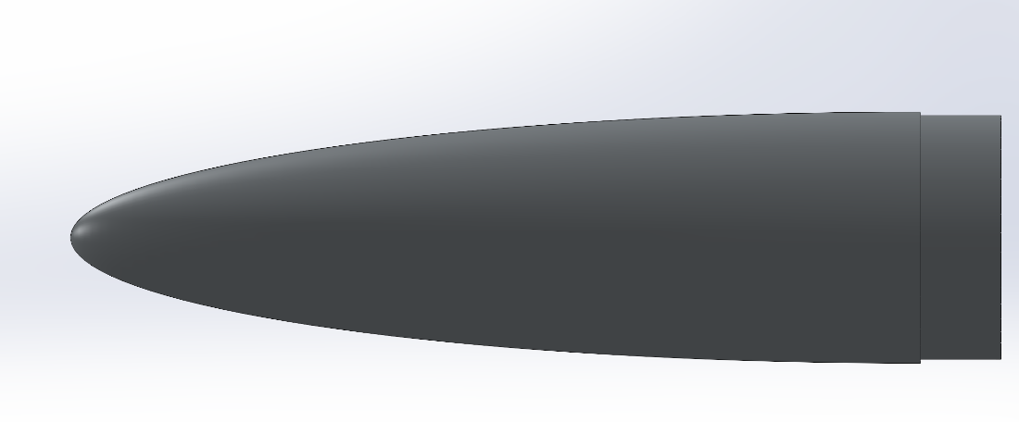
Note. This is a picture of the elliptical nose cone featured in the above idea.
The second high fidelity idea is a launch vehicle that uses dual deployment and has a parabolic tail cone and a Haack series nose cone. This nose cone is pictured in figure 3. The design utilizes an L class solid propellant motor. The fins, nose cone, and tail cone will be 3D printed and made of ABS. The hull will be made of blue tube and the payload will utilize chemical energetics to deploy a balloon-like structure. This is a high-fidelity idea because some of the technologies like the Haack series nose cone will drastically optimize aerodynamic stability. The L class motor adequately gets the vehicle to the target altitude and the team is familiar and comfortable working with all the selected materials.
Figure 3
Haack series nose cone concept
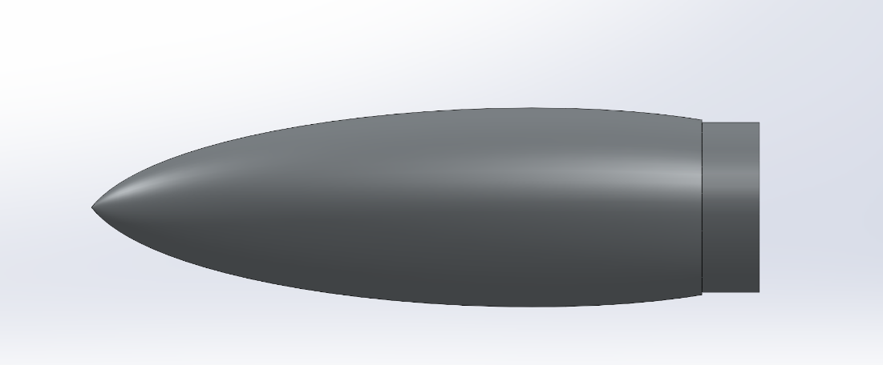
Note. This is a picture of the Haack series nose cone featured in the above idea.
The final high-fidelity idea is a rocket that is dual deployment with a parabolic tail cone and an Ogive nose cone. The launch vehicle utilizes an L class solid propellant motor as a source for thrust. The fins, nose cone, and tail cone will be made of PETG and manufactured in-house. The hull will be made of fiberglass to decrease weight. The payload is a thrust-vectoring monocopter, a single propeller drone that utilizes a flight controller to perform a thrust-vectored descent with its thrust-vectoring fins and servos. This concept is high fidelity because the PETG components are exceptionally durable, the fiberglass component results in a favorable center of pressure and center of gravity, and the payload is relatively feasible. This design is pictured in figure 4.
Figure 4
High fidelity concept 3
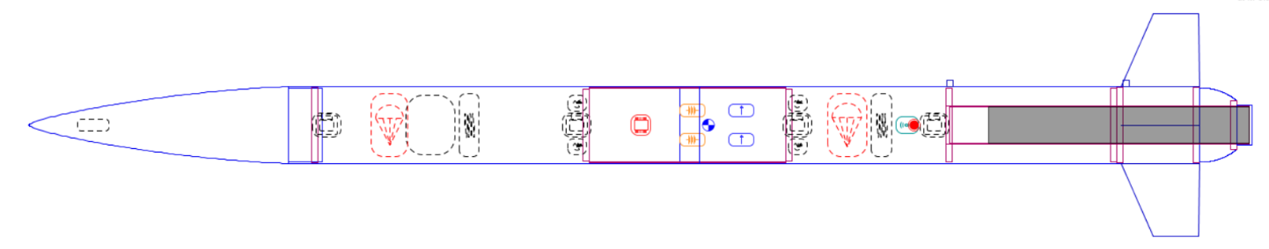 Note. This is a picture of one of the third high fidelity concepts.

100 Initial Concepts
Brainstorming Ideas
- A rocket that is dual deployment with a parabolic tail cone and a Haack series nose cone. It utilizes an L class solid propellant motor. The fins, nose cone, and tail cone will be 3D printed and made of ABS. The hull will be made of blue tube and the payload will utilize chemical energetics to deploy a balloon-like structure.
- A rocket that is dual deployment with a parabolic tail cone and an Ogive nose cone. It utilizes an L class solid propellant motor. The fins, nose cone, and tail cone will be 3D printed and made of PETG. The hull will be made of fiberglass and the payload will be a monocopter that utilizes a control loop to descend.
- Rocket that utilizes a live animal as a STEMnaut and two smaller solid propelled motors for propulsion
- High-power model rocket with dual stage J/L class style motors, lightweight body frames, and 2 stage deployment.
- Launch rocket with catapult and land rocket back onto trampoline set on top of a large structure.
- Experimental solid propellant rocket style propellant with a 3-stage deployment, and a payload that utilizes CO2 thrusters for controlled descent.
- Electric thruster rocket run by lithium-ion batteries complete with a solar-powered payload that lands also via electric thrusters.
- Nuclear powered rocket with reactor core inside the payload that powers and expels nuclear energy out of the propulsion system.
- A rocket with no deployment stages that utilizes its motor to land the rocket vertically after flight, like SpaceX landings.
- Rocket that lands like the space shuttle by gliding down with wings/fins that provide lift.
- Rocket that is one with the payload, and utilizes drone propellers to fly, descend, and control orientation.
Biomimicry Ideas
- An RC airplane launches a lower powered rocket once it reaches a certain altitude – based off study of winged animals.
- A solid propelled vehicle with hollowed out centering rings and bulkheads – based on birds with hollow bones.
- A bipropellant motor with protruding propellant tanks – based off the back of a camel.
- A solid propellant vehicle with a navigation system that uses echo location- based on dolphins.
- A vehicle with a payload that utilizes the motions of a dragonfly wing for agile and precise maneuvering.
- A solid propellant rocket that utilizes a payload that lands softly using a mechanism that mimics a hummingbird.
- A solid propellant rocket that has a payload that lands in the ground by utilizing a shock absorbing mechanism that a woodpecker uses.
- A vehicle body with protrusions like a humpback whale's tubercles to induce turbulence near the surface of the vehicle so the rocket will fly further.
- A solid propelled rocket with a payload that is deployed as a glider that is based off bat wings.
- A solid propelled rocket with a nosecone modeled after a dolphin's nose and a tail cone modeled from a dolphin's tail.
Crap Shoot
- A vehicle with a skid landing recovery system that uses skis to touch down, that is made of fiberglass and utilizes active dynamic stability by actuating the fins.
- A vehicle that utilizes a ballistic descent by creating a large surface area for a drag force to slow it down that is made of balsa wood and focuses on environmental sustainability by being made of biodegradable materials and using ecosystem friendly propellants.
- A vehicle that has a glider landing system, is made of balsa wood, and utilizes an electromagnetic launch mechanism.
- A vehicle that has a helicopter capture recovery system, is made of aluminum, and has fins that adapt shape based on altitude to minimize drag and maximize stability.
- A vehicle that utilizes a rocket skid landing system, is made of aluminum, and utilizes a dynamic stability system for stability.
- A vehicle that utilizes a glider landing system, is made of carbon fiber, and has adaptive fins.
- A vehicle that is landed by propulsion, is made of ABS, and utilizes piezoelectric energy harvesting so that heavy on-board batteries are not needed.
- A vehicle that utilizes a rocket skid landing system, is made of carbon fiber, and is focused on environmental sustainability by using biodegradable materials and environmentally friendly propellants.
- A rocket that utilizes a rocket skid landing system, is made of PETG, and utilizes piezoelectric energy harvesting so that heavy on-board batteries are not needed.
- A vehicle that is landed by propulsion, is made of PETG, and is 3D printed
- A rocket which uses gas thrusters to propel itself, and backup thrusters to land on the descent.
- A water-powered rocket which uses principles of Newton’s third law to propel the vehicle into the atmosphere. The remaining frame could be made to acquire drag to slow descent.
Forced Analogy Ideas
- A rocket with a padded exterior, sturdy metal frame, modular components, sleek and compact body.
- A small, lightweight rocket with a conjoining mechanism for modular assembly. It has a curved and slim body for agile maneuvers. Additionally, it is made from lightweight materials.
- Long-bodied rocket with flexible components and optimized for high-speed travel.
- A fast and agile rocket designed for tireless ascent with flexible exterior components able to withstand aerodynamic stresses.
- Rocket with long, wear-resistant tethers and soft, flexible straps for a low sitting launch orientation.
- Rocket with long, wear-resistant characteristics of shoelaces and the flexibility and speed of a long-distance run.
- Rocket that combines the curvature of a paperclip in its body and flexible components.
- A vehicle with a solid propellant motor attached to its center of mass with removable cushions to brace its landing.
- A rocket with paper clips used as shear pins and shoelaces used as shock cords.
- Rocket with a soft exterior inspired by the word “Heaven” with a sturdy sold metal frame. This will allow more kinetic energy to be absorbed upon landing.
- A rocket with a flexible and fast-igniting booster system that provides adequate thrust. It contains tiresome endurance and converts it into reliable propulsion.
- A rocket with solar panels on its exterior to harness energy from celestial bodies during flight. Uses renewable energy as a source for powering its electronic sensors and controllers.
- Sleek and robust metal framed rocket that minimizes aerodynamic drag with a cushioned payload bay.
- A rocket with a lightweight and curved fairing design that enhances aerodynamic efficiency. It has a thin profile to reduce drag during its ascent. Payload deployment decreases its weight, meaning smaller and cheaper parachutes can be used for recovery.
Anti-problem Ideas
“How can a rocket launch be unsuccessful”
- A rocket with a potato for a parachute so that it will lawn dart and destroy itself during descent. Aspect: safe recovery
- A solid propelled rocket with its motor at its nose cone so that its thrust mechanism destroys itself with heat and propulsion. Aspect: heat transfer
- Use a stick of dynamite as the source of propulsion so that the rocket explodes during launch. Aspect: steady propulsion
- Use cooked pasta as shock cords so that the rocket separates from the parachutes, lawn darts, and destroys itself. Aspect: descent consideration
- Build a rocket with paper as its structural material to maximize deformation caused by drag. Aspect: structural integrity
- A rocket that deploys its parachutes during launch so that the drag induced destroys the rocket. Aspect: controlled deployment
- A ceiling fan-propelled rocket that cannot generate enough thrust to leave the ground. Aspect: thrust generation
- A rocket that carries rocks as a payload and releases them at apogee causing dangerous projectiles to hurl toward spectators to get disqualified per FAA (Federal Aviation Administration) regulations. Aspect: safety consideration
- A rocket that is designed without sensors so that flight data is not tracked, and post flight error analysis cannot be conducted. Aspect: data logging
- A rocket that uses dynamite as a separation charge. This will destroy the rocket during parachute deployment. Aspect: separation event consideration
- A rocket with an early 1990s GPS and flight control system that is prone to inaccuracy and lacks accurate control. Aspect: Telemetry
Battle of Perspectives
- An electromagnetic rocket which utilizes the Earth's magnetic field to generate thrust upwards. The same principles would be used to slow the rocket down on descent.
- A solid-powered rocket that could use solar cells to generate enough energy to separate the rocket. Solar cells could be placed around the body of the rocket so as not to cause drag.
- A solid-powered rocket which uses telemetry through radio signals to separate vehicle body and deploy payload. These signals would be independent from other frequencies being used at launch, so that the separation could happen independently.
- A solid-powered rocket which carries an autonomous payload, which uses a stereovision camera to detect appropriate landing sites on descent. This would allow for a higher chance of orientating the rocket correctly during landing.
- A liquid-fueled rocket with a detachable nosecone that doubles as the vehicle payload. This top-heavy orientation allows for an easier ejection on descent, as the payload will be oriented towards the ground.
- A solid-powered rocket which uses the gravitational force of the moon to further apogee and uses the same strategy to slow the descent.
- A static rocket which uses a large rubber band to launch into the sky, which also provides cushion for the rocket upon landing.
- A rocket using a reaction like Coke and Mentos to generate the force to launch it and a glider-based attachment to land safely.
- A rocket which uses hot air to rise quickly into the atmosphere, then strategically cools the air it so it falls in a controlled fashion.
- A solid-powered rocket that uses wing-like attachments to fly the launch vehicle and payload to the ground.
Morphological Chart Ideas
- Catapult propulsion, ogive nose cone, no tail cone, fiberglass body structure, dual stage deployment, and off the shelf altimeters for the vehicle. For the payload, spring-loaded ejection, free-fall descent, uncontrolled control, zip ties retention, and glue STEMnaut retention.
- Catapult propulsion, parabolic nose cone, parabolic tail cone, blue tube structure, single stage deployment, Apple Air Tag and recording iPhone for the vehicle. For the payload, Chemical energetic deployment, propeller thruster, drone flight computer, latch retention within bay, Velcro straps STEMnaut retention.
- Solid propellant motor, conic nose cone, conic tail cone, aluminum structure, three stage deployment, assortment of random sensors for the vehicle. For the payload, Pull out by main parachute deployment compressed gas thruster descent, Arduino controller, magnets retention, fishing line STEMnaut retention.
- Solid propellant motor, parabolic nose cone, parabolic tail cone, blue tube body, single stage deployment, off the shelf altimeter for the vehicle. For the payload, magnetic release deployment, glider descent, Raspberry Pi controller, hooks for retention in the bay, rubber bands for STEMnaut retention.
- Solid propellant motor, elliptical nose cone, conic tail cone, dual stage deployment, fiberglass structure, Arduino based sensing system for the vehicle. For the payload, piston ejection deployment, plasma thruster descent, remote-controlled controller, rail retention within bay, hold on for dear life for STEMnaut retention.
- Bi-propellant liquid engine, Haack series nose cone, power series tail cone, carbon fiber structure, dual stage deployment, off the shelf altimeters for the vehicle. For the payload, Spring-loaded ejection deployment, propeller thruster descent, Arduino controller, hooks for retention in bay, hold on for dear life for STEMnaut retention.
- Bi-propellant liquid engine, elliptical nose cone, parabolic tail cone, fiberglass structure, three stage deployment, visual observation sensing for the vehicle. For the payload, Piston ejection deployment, glider descent, Arduino controller, latch retention within bay, glue STEMnaut retention.
- High velocity water-propellant, ogive nose cone, no tail cone, aluminum structure, allow rocket to free fall to the ground, assortment of random sensors for the vehicle. For the payload, Spring loaded ejection deployment, propeller thruster descent, uncontrolled, latch for retention within bay, glue for STEMnaut retention.
- Gas/liquid hybrid engine, Haack series nose cone, power series tail cone, wood structure, large gust of wind lowers rocket gently to the ground, Apple air tag and recording iPhone sensing for the vehicle. For the payload, Chemical energetic deployment, free fall descent, drone flight computer controller, zip ties retention in bay, Velcro straps STEMnaut retention.
- Catapult propulsion system, parabolic nose cone, power series tail cone, carbon fiber body structure, single stage deployment, off the shelf altimeters for the vehicle. For the payload, chemical energetic deployment, compressed gas thruster descent, drone flight computer controller, magnets retention within bay, Velcro straps STEMnaut retention.
- Gas/liquid hybrid motor, conic nose cone, conic tail cone, blue tube body structure, dual stage deployment, Arduino based sensing system for the vehicle. For the payload, pulled out by main chute deployment, propeller thruster descent, Arduino controller, latch retention within bay, fishing line STEMnaut retention.
- Solid propellant motor, ogive nose cone, parabolic tail cone, fiberglass structure, dual stage deployment, off the shelf altimeters for the vehicle. For the payload, spring-loaded deployment, compressed gas thruster descent, drone flight controller, latch retention within bay, Velcro straps STEMnaut retention.
- Bi-propellant liquid engine, parabolic nose cone, parabolic tail cone, wood structure, allow rocket to free fall to the ground, visual observation of the rocket for sensing for the vehicle. For the payload, Magnetic release deployment, compressed gas thruster, raspberry pi controller, magnets for retention within bay, rubber bands for STEMnaut retention.
- High velocity water-propellant motor, ogive nose cone, power series tail cone, aluminum structure, single stage deployment, Arduino based sensing for the vehicle. For the payload, magnetic release deployment release, plasma thruster descent, raspberry pi, rail for retention within bay, rubber bands for STEMnaut retention.
- High velocity water-propellant motor, elliptical nose cone, elliptical tail cone fiberglass structure, three stage deployment, visual observation of rocket descent sensing for the vehicle. For the payload, piston ejection deployment, glider descent, remote-controlled controller, hooks for retention within bay, hold on for dear life STEMnaut retention.
- Gas/liquid hybrid motor, parabolic nose cone, conic tail cone, blue tube structure, single stage deployment, Apple Air tag and recording iPhone. For the payload, Magnetic release deployment, propeller thruster for descent, Raspberry Pi controller, rail for bay retention, and glue for STEMnaut retention.
- Solid propellant motor, conic nose cone, parabolic tail cone, wood structure, off-the-shelf altimeters for the vehicle. For the payload, Spring-loaded ejection deployment, free-fall descent, drone flight computer, latch bay retention, Velcro straps STEMnaut retention.
- Solid propellant motor, conic nose cone, parabolic tail cone, wood structure, large external force lowers rocket to the ground, visual observation of rocket on descent for sensing for the vehicle. For the payload, Magnetic release deployment, propeller thruster for descent, Raspberry Pi controller, rail for bay retention, glue for STEMnaut retention.
- Bi -propellant liquid engine, conic nose cone, conic tail cone, aluminum structure, allow rocket to fall to the ground, an assortment of random sensors for the vehicle. For the payload, Piston ejection, compressed gas thruster descent, uncontrolled, latch retention within bay, rubber bands for STEMnaut retention.
- Gas/liquid hybrid motor, ogive nose cone, no tail cone, fiberglass body, dual-stage deployment, Arduino-based sensing system for the vehicle. For the payload, deployment pulled out by main chute, glider descent, Arduino controller, magnets retention within bay, fishing line STEMnaut retention.
- Solid propellant motor, ogive nose cone, elliptical tail cone, blue tube structure, dual stage deployment, off the shelf altimeters for the vehicle. For the payload, Spring-loaded ejection, propeller thruster, Arduino controller, zip ties bay retention, hold on for dear life STEMnaut retention.
- Bi-propellant liquid motor, elliptical nose cone, power series tail cone, aluminum structure, three stage deployment, off the shelf altimeters for the vehicle. For the payload, spring-loaded ejection deployment, glider descent, remote controlled controller, rail retention within bay, Velcro straps for STEMnaut retention.
- Solid propellant motor, elliptical nose cone, conic tail cone, dual stage deployment, fiberglass structure, Arduino based sensing system for the vehicle. For the payload, deployment pulled out by main chute, glider descent, Arduino controller, magnets retention within bay, fishing line STEMnaut retention.
- Gas/liquid hybrid motor, parabolic nose cone, conic tail cone, blue tube structure, single stage deployment, Apple Air tag and recording iPhone. For the payload, magnetic release deployment release, plasma thruster descent, raspberry pi, rail for retention within bay, rubber bands for STEMnaut retention.
- Bi-propellant liquid engine, elliptical nose cone, parabolic tail cone, fiberglass structure, three stage deployment, visual observation sensing for the vehicle. For the payload, spring-loaded ejection, free-fall descent, uncontrolled control, zip ties retention, glue STEMnaut retention.
- High velocity water-propellant, ogive nose cone, no tail cone, aluminum structure, allow rocket to free fall to the ground, assortment of random sensors for the vehicle. For the payload, Spring-loaded ejection deployment, free-fall descent, drone flight computer, latch bay retention, Velcro straps STEMnaut retention.
- Catapult propulsion, parabolic nose cone, parabolic tail cone, blue tube structure, single stage deployment, Apple Air Tag, and recording iPhone for the vehicle. For the payload, magnetic release deployment, glider descent, Raspberry Pi controller, hooks for retention in the bay, rubber bands for STEMnaut retention.
- Gas/liquid hybrid motor, parabolic nose cone, conic tail cone, blue tube structure, single stage deployment, Apple Air tag and recording iPhone. For the payload, piston ejection deployment, glider descent, remote-controlled controller, hooks for retention within bay, hold on for dear life STEMnaut retention.
- Solid propellant motor, conic nose cone, parabolic tail cone, wood structure, off-the-shelf altimeters for the vehicle. For the payload, Magnetic release deployment, propeller thruster for descent, Raspberry Pi controller, rail for bay retention, and glue for STEMnaut retention.
- Catapult propulsion, parabolic nose cone, parabolic tail cone, blue tube structure, single stage deployment, Apple Air Tag and recording iPhone for the vehicle. For the payload, Magnetic release deployment, compressed gas thruster, Raspberry Pi controller, magnets for retention within bay, rubber bands for STEMnaut retention.
- Solid propellant motor, elliptical nose cone, conic tail cone, dual stage deployment, fiberglass structure, Arduino based sensing system for the vehicle. For the payload, Magnetic release deployment, propeller thruster for descent, Raspberry Pi controller, rail for bay retention, glue for STEMnaut retention.
- Bi-propellant liquid engine, conic nose cone, conic tail cone, aluminum structure, allow rocket to fall to the ground, an assortment of random sensors for the vehicle. For the payload, Spring loaded ejection deployment, propeller thruster descent, uncontrolled, latch for retention within bay, glue for STEMnaut retention.

Concept Selection
After the completion of concept generation, tools like the Binary Pairwise Comparison, House of Quality, Pugh Charts, and the Analytical Hierarchy Process (AHP) were used to evaluate the options. These charts use an analytical process to numerically determine the best concepts based on customer needs. Overall, these translate qualitative ideas onto a quantitative scale to make informed design decisions.

Binary Pairwise Comparison
The binary pairwise comparison chart is used to determine the importance weight factor of each customer's needs listed and to rank them accordingly. Figure 5 presents the binary pairwise comparison used to determine the weight factors for the house of quality. It helped team 502 to determine the customer needs to be prioritized in the final design. The process was carried out by asking if the row is better or more useful than the column. If the customer's need in the row was more important than the column, a 1 was assigned to that part of the matrix, if it was less important, a 0 was assigned, and if it was the same a dash (-) was assigned. This was the case for the main diagonal of the matrix. The transposed position was assigned the opposite value. The process was repeated until the entire matrix was populated. The columns and rows were then summed to determine an “Importance Weight Factor” that is translated to the House of Quality Chart. From this it is determined that the most important customer needs are that the rocket and payload can withstand flight stresses, the vehicle can track and store required flight data, vehicle has correct permits and licenses, the launch vehicle and payload are recovered safely, and that the rocket minimizes danger towards surroundings. This matches up with the goals of the project as defined by the customer.
Figure 5
Binary Pairwise Comparison Chart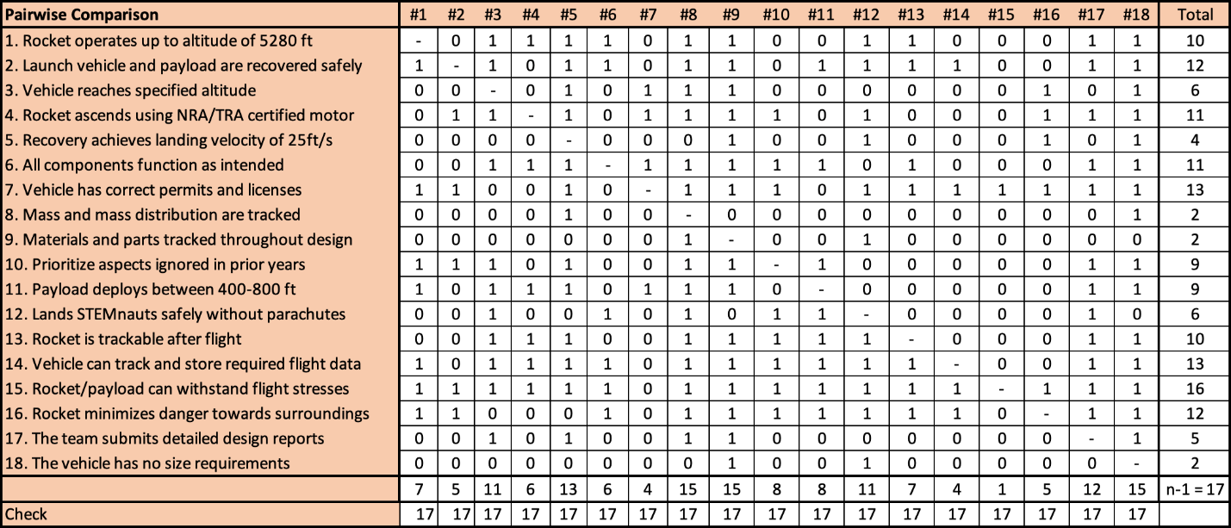Note. This figure is used to compare the importance of customer needs with each other.

House of Quality
The goal of the House of Quality is to translate customer needs into quantifiable design variables called engineering characteristics. The most attention should be given to these characteristics for the final design. Figure 6 is the House of Quality chart that was generated. A 1-3-5-7-9 scale was used, a value was assigned based on how much the characteristic would fulfill the appropriate customer need. To determine which characteristics were the most important for use in the Pugh chart, the top 5 Engineering Characteristics were chosen, this is because they fell above the relative weight value of 11.12% which was the median value. The 6th highest was also chosen just to ensure that a plethora of distinctive characteristics were being considered. The most important engineering characteristics in order from most to least important are measure vehicle altitude and velocity, generates thrust, deploys main parachute, minimizes aerodynamic stress, deploy drogue parachute, and secures STEMnauts in payload flight. These characteristics best reflect customer values and can be used next to generate the next stage of the design selection which are the Pugh charts and the analytic hierarchy process for further comparison. The discarded characteristics were storing flight data, detaching payload from vehicle, reducing excess vibrations, and reducing drag.
Figure 6
House of Quality Chart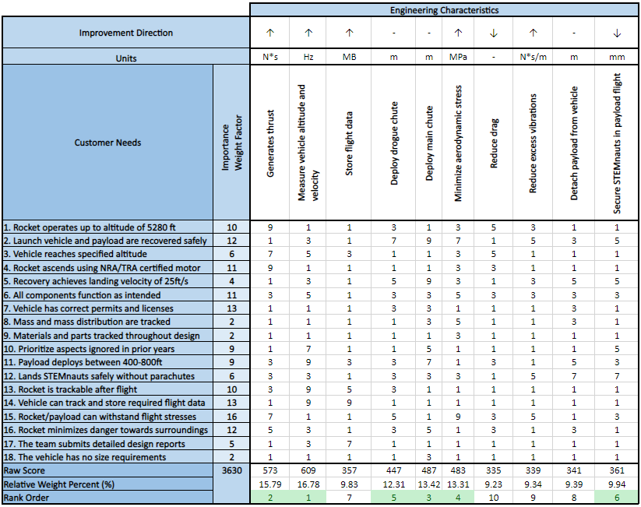Note. This chart is used to translate Customer Needs into Engineering Characteristics.

Pugh Chart
The Pugh chart analyzes the most important engineering characteristics obtained from the house of quality against design concepts. Figure 7 displays the first Pugh Chart which uses last year's rocket design, Zenith 1, as the reference datum. This vehicle performed decently last year and is comparable to many rockets in this year's competition in terms of stability, apogee, and mass. This means that because it is an average of many of the rockets, it can be used to compare the teams design concepts against. The concepts used in the Pugh charts are the medium and high-fidelity concepts from concept generation. The rows are the engineering characteristics, the columns are the concepts, and in the leftmost column is the datum that the concepts are compared against which is last year's design. Each element is assigned a “S,” “+,” or “-.” An “S” indicates the concept, and the datum are similar for the given engineering characteristic, a “+” indicates the concept is better than the datum, and a “-” indicates the concept is worse than the datum. The elements are then summed up and displayed at the bottom of the chart. The concepts of “dual staged powered ascent,” “Aluminum body, conic nose and tail cone, and gas thruster descent,” and “elliptical nose and tail cone, fiberglass structure, and magnetic deployment” were ruled out because they each had many “-” and very few “+.”
The second Pugh chart is pictured in Figure 8 and is a further refinement of ideas. The “hollowed out centering rings and bulkheads, blue tube structure, and parabolic nose and tail cone” was chosen as a datum for the second Pugh chart because it had an average number of pluses and an average of minuses, making it a great baseline for further evaluation. From the second Pugh chart, the concept of “the parabolic tail cone, Haack series nose cone, blue tube, and ABS, and bouncing payload recovery” was eliminated because it had the highest number of “-.” The concepts of “blue tube structure, ogive nose cone, and gas thruster descent,” “blue tube structure, parabolic nose cone and tail cone, glider descent, and magnetic release,” and “parabolic tail cone, Ogive nose cone, PETG and fiberglass materials, and a monocopter payload” were kept because they displayed a significant advantage over the datum. These three concepts would then be used in AHP.
Figure 7
Pugh Chart 1
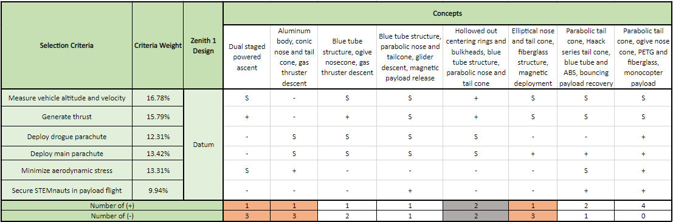 Note. This chart compares concepts against a market datum for a given criteria. The third, fourth, seventh, and eight concepts were selected for the second Pugh chart. The fifth concept was selected as the new datum.
Figure 8
Pugh Chart 2
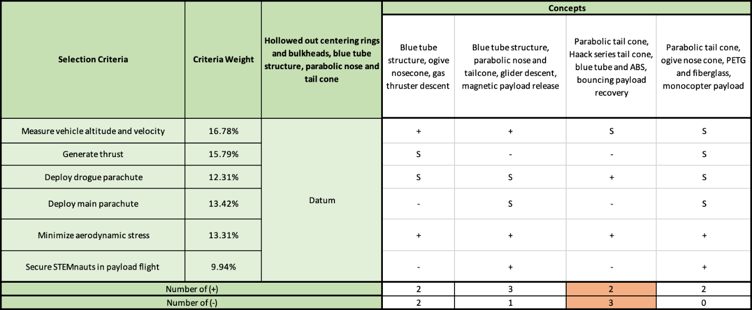
Note. This chart compares concepts against a baseline concept for a given criteria. The third concept was removed from contention.

Analytical Hierarchy Process
The analytical hierarchy process is broken down into several stages and described in this section. The criteria comparison matrix is shown in Figure 9. This matrix is designed so that each selection criteria is compared against one another to determine the most important criteria in the decision process by quantifying small qualitative decisions. A 1-3-5-7-9 scale is used and if the column was more important than the row, a whole number was placed in correlation with how much more important the criterion in the column is. The inverse was taken in the transposed element of the matrix. The elements were summed up and displayed in the bottom row.
A new matrix was then formed, the normalized criteria comparison matrix shown in figure 10. This matrix normalizes the columns of Figure 9 by the sum of the column. Then the rows of the matrix were summed and divided by the number of elements in the row. This generated the criteria weights, W. The highest weighted criteria weight was deploying the main parachute, and the lowest weighted criteria weight was measuring the vehicle altitude and velocity.
Figure 9
Criteria Comparison Matrix
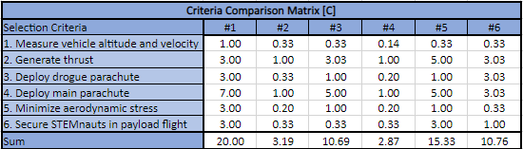
Note. This matrix is used to compare the selection criteria against each other.

Figure 10
Normalized Criteria Comparison Matrix
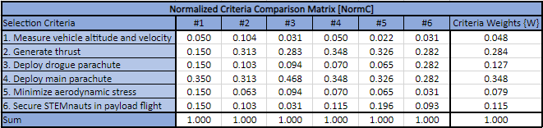
Note. This matrix is used to determine the Criteria Weights.
To ensure that there were no biases in the decisions and to check the consistency of the results, further analysis was conducted. Figure 11 shows the results of this analysis. The first column is the weighted sum vector. It is calculated by multiplying the criteria comparison matrix by the criteria weights. The criteria weights generated from figure 10 are listed in the second column. The third column shows the consistency vector found by dividing the weighted sum vector by the criteria weights. The consistency vector was then summed and divided by the number of elements to generate, the average consistency. The random index value (RI) was determined by referencing a table for 6 elements. The equation:
$CI= \frac{λ-n}{n-1}$ (1)
where CI is the consistency index and n is the number of elements, was used to find CI. The team found the CI value to be 0.116. The consistency ratio (CR) was then found using the equation:
$CR= \frac{CI}{RI}$ (2)
A value of CR < 0.1 indicates that the selection process was unbiased. The results of the consistency check showed that the team’s selection process was unbiased as the CR value was equal to 0.093, which is less than 0.1.
Figure 11
Consistency Check
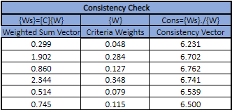
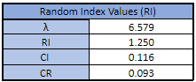
Note. This check is used to ensure there is no bias in the selection process.
The criteria comparison matrix, normalized criteria comparison matrix, and the consistency check process were repeated to compare the top three concepts against each other for each selection criteria. These charts are found in Appendix C. The results of these comparisons are found in Figure 12 where the design alternative priorities, Pi, are listed for each concept and selection criteria. The alternate values in Figure 13 were found by transposing the final rating matrix then multiplying it by the criteria weights found in figure 10. The highest alternative value was selected as the superior design because it best fulfills the customer's needs. The final concept chosen was the vehicle with the parabolic tail cone, ogive nose cone, made of PETG and fiberglass, and having a monocopter payload.
Figure 12
Final Rating Matrix
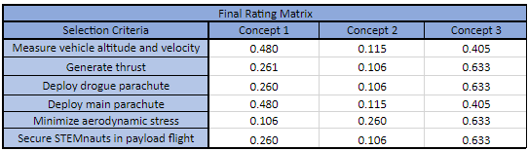
Note. This matrix summarizes the Pi values for each concept and selection criteria.
Figure 13
Alternate Value Table
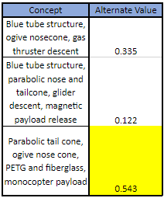
Note. This table summarizes the alternate values for each concept. The third concept had the greatest alternate value of 0.543 and was selected.

Final Selection
Figure 14
CAD drawing of the final design
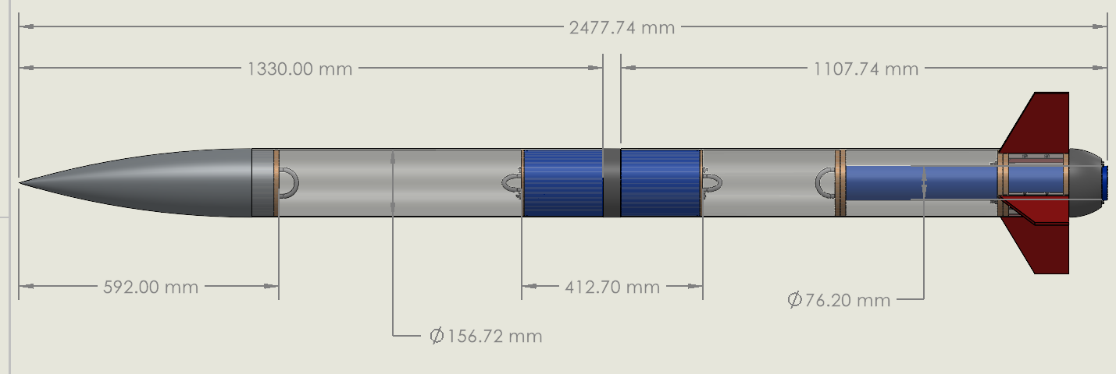 Note. This is a preliminary CAD drawing of team 502’s final design.

Figure 15
CAD drawing of the final design, outer body view
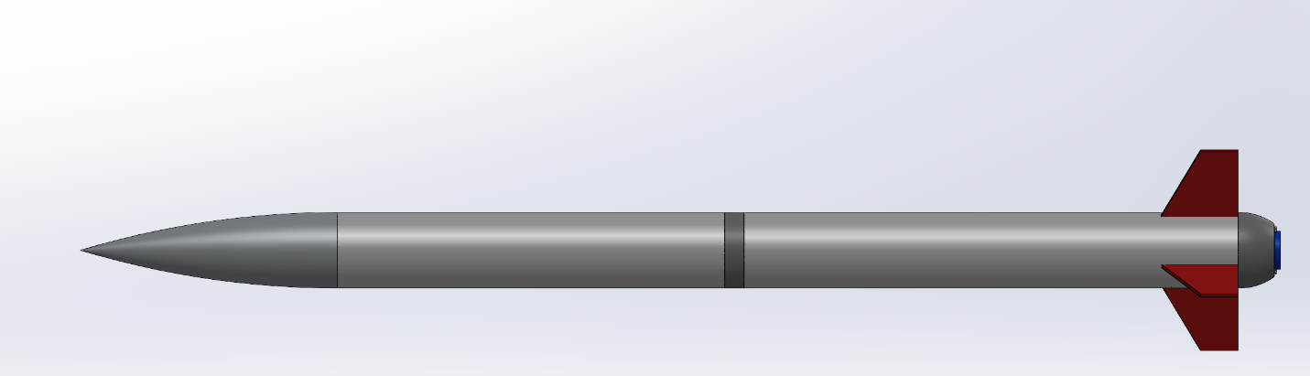Note. This is a preliminary CAD drawing of team 502’s final design.
After reviewing ideas via the house of quality, Pugh chart, and the analytical hierarchy process, the final selection was decided as the launch vehicle containing a solid propellant motor, dual-stage deployment, parabolic tail cone, Ogive nose cone, and a fiberglass body. The payload will be a thrust-vectoring monocopter, a single propeller drone with a flight controller to perform a thrust-vectored descent with thrust-vectoring fins and servos. This decision was based off the results from the alternate value table. The concept with the greatest alternate value was selected as it represented the most applicable solution to meeting the customer needs and requirements.
The vehicle design is pictured in Figures 14 and 15. This vehicle will be aerodynamically stable and will provide enough thrust to get to the target altitude and satisfy all the customer's needs. The fins, nose cone, and tail cone will be made of PETG filament due to its structural and heat resistive properties. The vehicle body will be made of fiberglass because it is light weight, durable, and will not deform with humidity. The shape of the nosecone will be ogive because it will reduce drag and is easy to manufacture. The propulsive system will be solid propellant because this is the easiest for the team to access and work with. The payload will be a thrust vectoring monocopter and the team believes it can satisfy the payload requirements this way.

Spring Project Plan
The completion of Chapter One concluded the first half of Team 502’s NASA Student Launch Project. All the processes and methods used in Chapter One resulted in a great understanding of all that encompasses the project and the future steps required for its successful completion. These insights were used to create the Spring Project Plan. The Spring Project Plan serves as the roadmap and project maturity reference for all work required in Chapter Two. This plan is visualized through the Gantt chart shown in Figure 16.
Figure 16
Gant Chart outlining the Spring Project Plan

Chapter Two: EML 4552C

Spring Plan

Project Plan.

Build Plan.

Appendices

Appendix A: Code of Conduct

Mission Statement
The mission statement for senior design team 502 is to advance understanding, inspire, and innovate through solving advanced propulsion and launch vehicle challenges. Team 502 will work diligently with stakeholders to ensure quality and results.
Outside Obligations
All outside obligations will be logged into a shared Outlook calendar to alleviate team scheduling difficulties. This provides the team with quick insight into the most convenient times/days for team member availability. These obligations may change throughout the year.
Atzimba Avellaneda’s outside commitments include being Treasurer for the Society of Automotive Engineers (SAE), Vice Chair for the American Institute of Aeronautics and Astronautics (AIAA), and a member of the Society of Hispanic Professional Engineers (SHPE). She is also the Range Safety Officer of the project and club.
Nicholas Hux’s outside obligations include being the vehicle and propulsion team lead for AIAA (5 hours/week). He has also been involved in the creation of a startup company (10 hours/week).
Jake Miller currently performs undergraduate research at the RTHM Lab under Dr. Taylor Higgins (10 hours/week). He is also the avionics team lead for the FAMU-FSU chapter of the AIAA (American Institute of Aeronautics and Astronautics) (5 hours/week).
Jacob Schmitt’s outside obligations include master's courses for the BS-MS program and being the Project Lead for the Zenith program in the FAMU-FSU chapter of AIAA and working as a teaching assistant (10 hours/week) for Dr. McConomy in the 4550 Engineering Design Methods course.
Connor Zhou’s outside commitments include his senior course load and being a team lead for the Zenith program in the FAMU-FSU chapter of AIAA. Additionally, he holds membership in ASME, ASU, and SASE (10 hours/week).
Team Roles
Duties that do not fall under the designated roles will be split between the senior design team according to availability and interest. It is a priority to ensure work is evenly divided amongst the team. Table 1 lists the respective team roles for each person.
Table 1
Team roles for the 502 senior design projects.
Team Member | Team Role
Atzimba Avellaneda | Materials Engineer
Nicholas Hux | Vehicle Engineer
Jake Miller | Software Engineer
Jacob Schmitt | Systems Engineer, Point of Contact
Connor Zhou | Controls Engineer

The materials engineer is responsible for researching and selecting materials to improve efficiency, reduce weight, and enhance the quality of the rocket design. The role involves developing and overseeing the fabrication and assembly of the rocket components. In addition, collaborating with the other leads making the necessary modifications to the design throughout the length of the project are also entailed to this role.
The vehicle engineer is responsible for designing the thrust structure of the rocket so that powered ascent complies with the competition parameters. This role is also in charge of designing the airframe and conducting flight simulations. In addition, this person helps the materials engineer to fabricate the airframe and thrust structure. Finally, they are responsible for the testing and integration of the thrust vehicle system.
The software engineer is responsible for the programming of onboard electronics and ensuring data collection during launch. This role is essential to generate a full understanding of how successful flight is, based on certain data such as apogee and maximum velocity. The software engineer is also responsible for coordinating with the controls engineer to program the payload and separate the rocket at appropriate times during flight.
The systems engineer oversees ensuring each system, subsystem, and component of the rocket works in tandem with one another. In addition to this, the system engineer oversees quality assurance, systems architecture, integration and testing, mission planning and execution, documentation, funding acquisition, part ordering, budgeting, meeting coordination, and post-flight analysis.
The controls engineer is responsible for the design and fabrication of the payload and its return method, which requires expert knowledge of control laws. Additionally, they will strategize and implement the rocket’s parachute deployment method. These responsibilities require collaboration with the design, software, and vehicle engineers.
As the project develops these roles will be altered to accommodate new tasks and functions. The team will constantly verify that each role has a shared workload and will adjust if this is not the case. Other duties will be voted on and assigned by the team as they arise.
Communication
The senior design team will use Microsoft Teams for file sharing and communication involving project contributors that are outside of the design team. This includes meeting announcements, general project questions and answers, and any communication intended to reach the entire AIAA chapter pertaining to NASA Student Launch. The team will organize the files on a weekly basis.
Also, the senior design team will communicate through an iMessage group chat dedicated to issues involving only the senior design team and inquiries that require faster response time. Messages should be acknowledged within 36 hours. If a message is not acknowledged, the team should call the member who did not respond.
The team organizes regular communication through regular “Scrum” meetings. Scrum meetings will take place every Monday, Wednesday, and Friday, and last a maximum of 10 minutes. In these meetings, each team member will quickly review the items they have completed since the previous Scrum and all the tasks they intend to complete before the next Scrum. Team members will additionally coordinate any connections they need to make with any other team member(s) in order to get tasks done.
Professional communication will occur through email. This includes correspondence with the sponsor, Dr. McConomy, other collaborators, and the FAMU-FSU facility. One person will oversee sending the email and carbon copying (“CC-ing”) all the other members. Jacob Schmitt will be the designated point of contact.
Dress Code
The dress code for the 502 senior design team will be business casual for presentations. Specifically, this includes khaki pants or slacks, and a button-down shirt with no pattern. The team decided that neutral colors will work the best (grey, white, navy blue, etc.) because these colors will not distract the audience. The team should also wear close-toed dress shoes and a belt.
The dress code for meetings with sponsors will be khaki pants or shorts and a button-down or collared shirt. Team members are expected to wear close-toed shoes to these meetings. It is important that the team conveys professionalism to the sponsor.
For senior design day, the team is expected to be in business professional attire. This will include a uniformly colored blazer, pants, and button-down shirt.
Attendance Policy
The team will meet four times a week. Three of these meetings will be the aforementioned “Scrum” meetings on Monday, Wednesday, and Friday. The fourth meeting consists of a regular meeting on Wednesday nights at 7pm, where the entire AIAA Zenith club meets to work on the rocket.
Based on “When2Meet” data the twenty-minute meetings will be on Monday from 5:00PM to 5:20PM and on Friday from 3:00PM to 3:20PM. The hour-long meetings will occur on Tuesdays and Thursdays from 7:30PM to 8:30PM. Wednesdays are reserved for individual work and for AIAA meetings.
Members of senior design group 502 are asked to let the team know if they plan to miss a meeting at least 24 hours in advance. If members are unable to attend a meeting, they are asked to find alternate ways to assist the group in the assignment at hand or carry more load on future assignments. If 3 meetings are missed without a valid excuse, and the absent members do not assist the team in alternate ways, the team will sit down and attempt to determine why the absences are repeated and find a way to ensure everyone is supporting the project.
Notifying the Group
To communicate amongst the senior design team and notify each other, primary reminders will be through a text message group chat. To connect with other students involved in the project from AIAA, the senior design team will use Microsoft Teams to send updates, reminders, and other information.
Responding in a Professional Meeting
All meetings related to the 502 senior design team will be held in a respectful and professional manner. The input of each member will always be valued, and constructive criticism between teammates is encouraged given that it directly contributes to the overall success of the project. Critique from those more experienced, such as Dr. McConomy and sponsors, will always be appreciated and used to improve later work.
The meeting will be structured as follows. The team will write up an agenda prior to the meeting with the sponsor. The agenda will start with the most important questions and reports. An “important” agenda item will be determined by the team prior to the meeting. These items are constituted by how time sensitive and mission critical they are. After this, each team member will have the opportunity to give a short briefing to the sponsor. Then the sponsor will have an opportunity to give comments. Finally, the meeting will conclude with a discussion amongst the group and the sponsor.
The group will adopt a version of “Robert’s Rules of Order” to keep the meeting flowing productively. If a team member has a comment or wants to respond to something during the meeting and the discussion portion has not been reached, they should politely raise their hand and wait for acknowledgement from the sponsor.
Dealing with issues before contacting TAs or Dr. McConomy
Issues involving the engineering or design process will initially be brought to the entire senior design team, to get a myriad of different perspectives on the problem. After the second time an incident occurs from the same group member, a formal intervention meeting will be called. After the third infraction, then thoughtful group consideration and research will be conducted. If a solution is still not found, then the team will reach out to the team advisor for additional insight.
If these avenues are all unsuccessful, the team will hold a vote to determine if contacting the Senior Design teaching staff and Dr. McConomy for guidance is needed. If the vote receives a 75% majority, then the staff will be contacted. This process is reserved for code of conduct violations.
If a team member demonstrates a consistent habit of doing less work than other members or pushing their work onto others, the other team members will respectfully bring it up in one of the weekly meetings. This is to address the underlying cause of the behavior and work together towards a solution. If behavior fails to improve after the team intervention, then the team will look towards Dr. McConomy for further guidance.
Any significant interpersonal disputes that arise are expected to be addressed individually, between those involved. If the offending members do not seek to mend the relationship, the rest of the team will do their best to remain unbiased and ensure that the project's overall success is not put in jeopardy. If the dispute does result in a significant hindering of progress, then the issue will be brought to Dr. McConomy.
When to contact Dr. McConomy
The team plans on contacting Dr. McConomy during regularly scheduled office hours (Monday, Wednesday, Friday, 11:00 am – 12:00 pm) and after class for general assignment questions or simple issues. Questions or advice that require lengthier conversations will be arranged through email, in a fashion that aligns with everyone’s schedule.
What we need from Dr. McConomy upon contact
For contact involving questions or issues about the design process, the team requests helpful feedback and advice so that each deliverable can improve upon themselves. The team expects honesty if expectations are not being met and hopes for constructive criticism that could put the team back on track, should need be.
For contact involving issues regarding team members, the team asks for straightforward, unbiased advice on what actions can be taken to get the team back on track.
How to Amend
If any changes need to be made, the senior design team will communicate and discuss the potential changes. Any person on the team or Dr. McConomy can propose a change to the document. A unanimous vote will be required to move forward with making the changes. These votes will occur at the Thursday meeting, and it will be the first item on the agenda. After this, a meeting will be set up with Dr. McConomy to further discuss the potential amendments. His approval will be required to make them official. Once the new code of conduct is approved, all members must resign the amended copy.
Personality Test Results
To create a more collaborative and efficient work environment, all the senior design team members took a Jung Typology Test. The results of this test provide the team with the ability to better assess the overall team compatibility, as well as understand each member’s preferences and traits. After completing the recommended HumanMetrics Jung Typology Test, the results for the team are as follows:
- Jacob Schmitt: ESFJ
- Jake Miller: ENTJ
- Nicolas Hux: ENTJ
- Atzimba Avellaneda: INTJ
- Connor Zhou: INTJ
The team feels that better understanding each other’s personalities makes for a much better group dynamic by leveraging everyone’s different strengths and styles. Furthermore, understanding these results will promote effective communication and cohesive production.

Statement of understanding
Each signature below represents that team member’s understanding and agreement with every statement written in this document.

________________________________________ ___________________
Atzimba Avellaneda Date

________________________________________ __________________
Nicholas Hux Date

________________________________________ ___________________
Jake Miller Date

________________________________________ ___________________
Jacob Schmitt Date

________________________________________ ___________________
Connor Zhou Date

Appendix B: Targets and Metrics Complete List
Function | Target | Metrics
Generate thrust. | <5120 Ns | Impulse
Receive Launch Signal | 67 dBm | Receive Signal Strength Indicator
Ignites Propellant | 12 V | Voltage
Expels Matter | 500 kg/s | Mass flow
Measure vehicle altitude and velocity. | 20 Hz | Frequency
Store flight data. | 1 MB | Memory
Tracks Location | 4 Hz | Update rate
Deploy drogue chute. | 1491 m | Altitude
Deploy main chute. | 167 m | Altitude
Minimize aerodynamic stress. | 340 MPa | Yield Strength
Resist Pitch | 3 calipers | Stability margin
Resist Yaw | 3 calipers | Stability margin
Reduce drag. | 0.29 | Drag Coefficient
Reduce excess vibrations. | 0.8 N*s/m | Coefficient of damping
Keep vehicle together on ascent | 100 N | Shear Force
Generate separation force. | 100 kPa  12.09 N | Pressure  Force
Detach payload from vehicle. | 120 - 240 m | Altitude
Generate gravity opposing force on payload descent. | 31.1 N | Force
Stabilize flight of payload. | 3 calipers | Stability margin
Orientate payload for landing. | 90º | Vertical orientation
Dissipate kinetic energy in descent of payload. | 136 Nm | Energy
Minimize kinetic energy in payload landing. | 102 Nm | Force
Secure STEMnauts in payload flight. | 2 mm | Positional margin
Allow for ingress/egress after payload landing. | 100% | Transit percentage

Appendix C: Concept Selection Tables

Binary Pairwise Comparison Chart
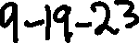

House of Quality Chart
Pugh Chart 1

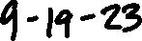
Pugh Chart 2
Criteria Comparison Matrix
Normalized Criteria Comparison Matrix
Consistency Check

Criteria Comparison Matrix 1
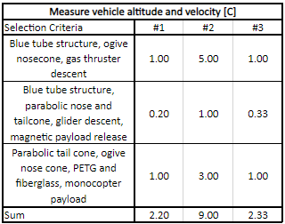
Normalized Criteria Comparison Matrix 1
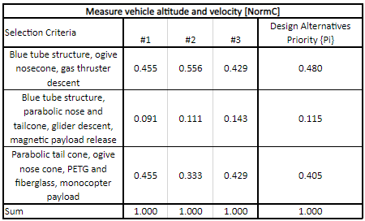
Consistency Check 1
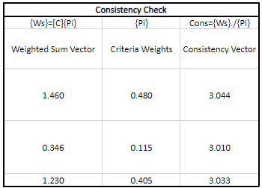
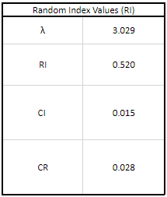
Criteria Comparison Matrix 2
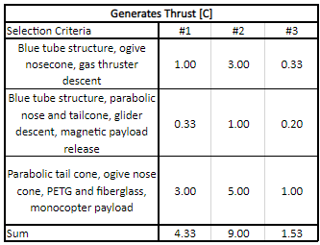
Normalized Criteria Comparison Matrix 2
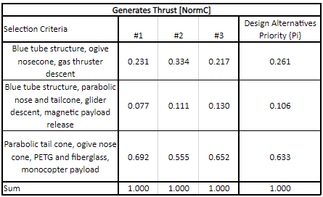
Consistency Check 2
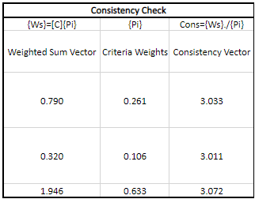
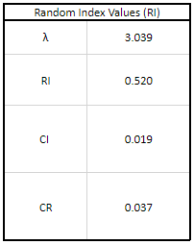
Criteria Comparison Matrix 3
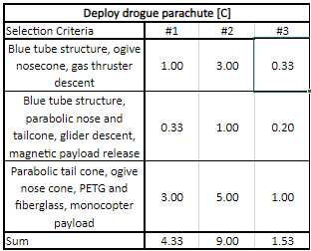
Normalized Criteria Comparison Matrix 3
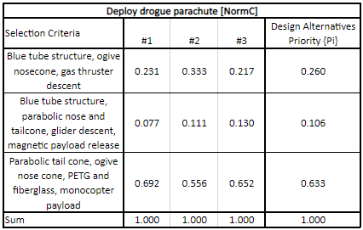
Consistency Check 3
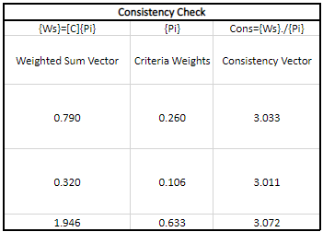
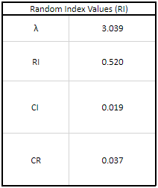
Criteria Comparison Matrix 4
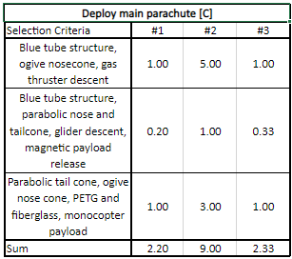
Normalized Criteria Comparison Matrix 4
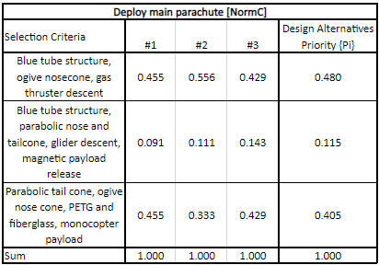
Consistency Check 4
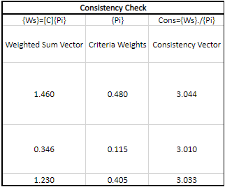
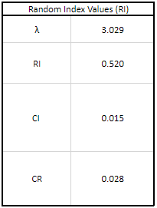
Criteria Comparison Matrix 5
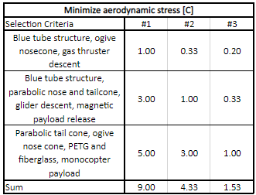
Normalized Criteria Comparison Matrix 5
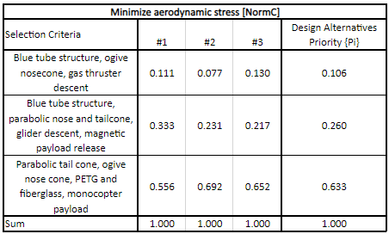
Consistency Check 5
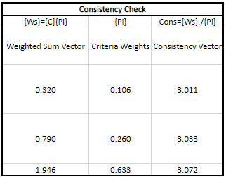
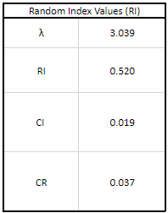
Criteria Comparison Matrix 6
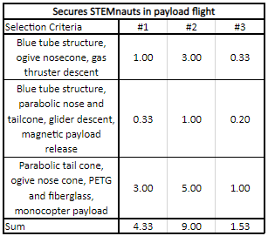
Normalized Criteria Comparison Matrix 6
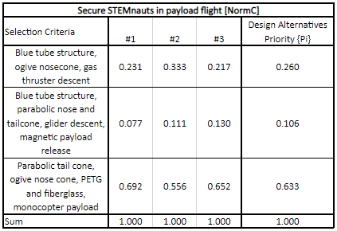
Consistency Check 6
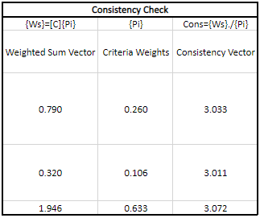
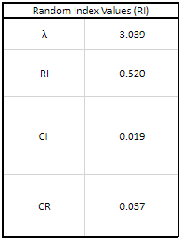
Final Rating Matrix
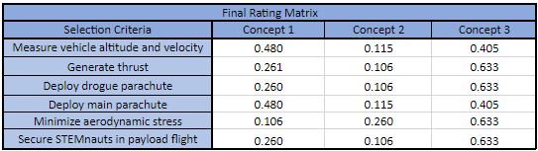
Alternate Value Table
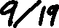

Appendix C: Target Catalog

Appendix A: APA Headings (delete)

Heading 1 is Centered, Boldface, Uppercase and Lowercase Heading

Heading 2 is Flush Left, Boldface, Uppercase and Lowercase Heading

Heading 3 is indented, boldface lowercase paragraph heading ending with a period.

Heading 4 is indented, boldface, italicized, lowercase paragraph heading ending with a period.

Heading 5 is indented, italicized, lowercase paragraph heading ending with a period.

See publication manual of the American Psychological Association page 62

Appendix B Figures and Tables (delete)
The text above the citation always introduces reference material such as a figure or table. You should never show reference material then present the discussion. You can split the discussion around the reference material, but you should always introduce the reference material in your text first then show the information. If you look at the Figure 1 below the caption has a period after the figure number and is left justified whereas the figure itself is centered.

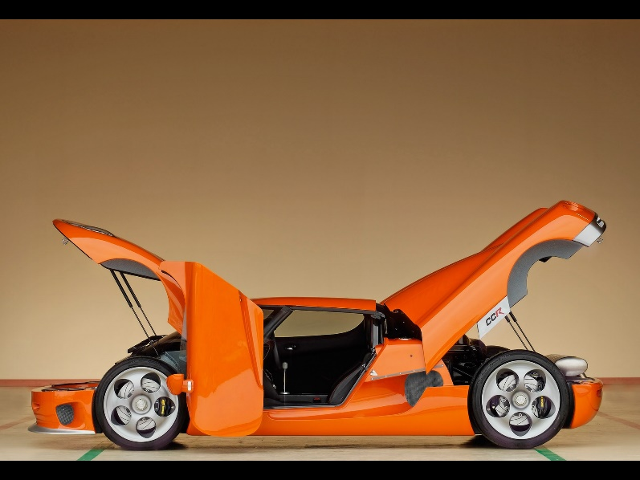
Figure. Flush left, normal font settings, sentence case, and ends with a period.
In addition, table captions are placed above the table and have a return after the table number. The second line of the caption provided the description. Note, there is a difference between a return and enter. A return is accomplished with the shortcut key shift + enter. Last, unlike the caption for a figure, a table caption does not end with a period, nor is there a period after the table number.

Table 3
The Word Table and the Table Number are Normal Font and Flush Left. The Caption is Flush Left, Italicized, Uppercase and Lowercase
Level of heading | Format
1 | Centered, Boldface, Uppercase and Lowercase Heading
2 | Flush Left, Boldface, Uppercase and Lowercase
3 | Indented, boldface lowercase paragraph heading ending with a period
4 | Indented, boldface, italicized, lowercase paragraph heading ending with a period.
5 | Indented, italicized, lowercase paragraph heading ending with a period.

References
There are no sources in the current document.

